4 x 1 HDMI Seamless Quad PIP Scaler

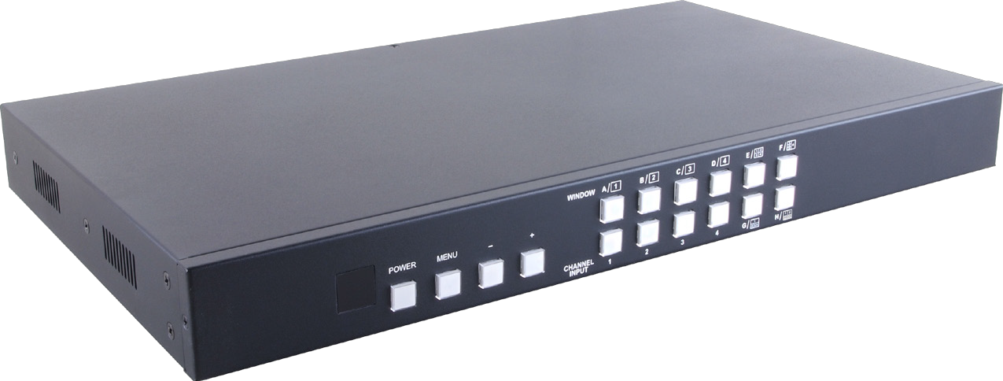

Operation Manual

SAFETY PRECAUTIONS
Please read all instructions before attempting to unpack, install or operate this equipment and before connecting the power supply.
Please keep the following in mind as you unpack and install this equipment:
• Always follow basic safety precautions to reduce the risk of fire,
electrical shock and injury to persons.
• To prevent fire or shock hazard, do not expose the unit to rain,
moisture or install this product near water.
• Never spill liquid of any kind on or into this product.
• Never push an object of any kind into this product through any openings or empty slots in the unit, as you may damage parts inside the unit.
• Do not attach the power supply cabling to building surfaces.
• Use only the supplied power supply unit (PSU). Do not use the PSU
if it is damaged.
• Do not allow anything to rest on the power cabling or allow any weight to be placed upon it or any person to walk on it.
• To protect the unit from overheating, do not block any vents or openings in the unit housing that provide ventilation and allow for sufficient space for air to circulate around the unit.

REVISION HISTORY

VERSION NO. DATE (DD/MM/YY) SUMMARY OF CHANGE
RDV1 | 07/10/15 | Preliminary Release

CONTENTS

1. Introduction............................................ 1
2. Applications ........................................... 1
3. Package Contents ................................ 1
4. System Requirements............................ 1
5. Features .................................................. 2
6. Operation Controls and Functions....... 3
6.1 Front Panel ........................................ 3
6.2 Rear Panel......................................... 4
6.3 Remote Control................................ 5
6.4 RS-232 Protocols ............................... 6
6.5 OSD Menu ......................................... 7
6.6 RS-232 and Telnet Commands .... 14
6.7 Telnet Control ................................. 23
6.8 WebGUI Control ............................. 25
7. Connection Diagram .......................... 30
8. Specifications ...................................... 31

1. INTRODUCTION
The 4 x 1 HDMI Seamless Quad PIP Scaler is a high performance, high speed zooming/shrinking system that can be easily configure and control for quad or picture-in-picture video processing. Allowing 4 different input sources to be freely selected and arranged on one single display with supporting output resolution up to 1080p and audio up to 8CH 192kHz for both input and output. Screen setting hot keys with IR, RS-232, WebGUI and Telnet allows instant control and witching on the output display.

2. APPLICATIONS
• Broadcasting room and control
• Surveillance room and control
• Public advertisement and control
• Digital Presentation

3. PACKAGE CONTENTS
• 1 x 4 by 1 HDMI Seamless Quad PIP Scaler
• 1 x Remote Control (CR-124)
• 1 x 12V/3A DC Power Adaptor
• 1 x Rack Ear Sets
• Operational Manual

4. SYSTEM REQUIREMENTS
Input source equipments such as DVD/Blu-ray players and PC/NB
devices and output HD TV/monitor.

5. FEATURES
• Seamless switching between channels and windows
• Zoom and Shrink 4CH input image and or to overlay them
• Supports PIP, POP and multi-windows display
• Supports OSD, RS-232, Telnet, Remote and on-panel controls
• Fade-In-Out, Chromakey, Mirror and Rotation (90˚ left & right and
180˚ up & down) functions
• 8 Screen setting hot keys and extra 4 customized favorite screen
setting
• Supports individual channel size and position adjustment
• Supports output image logo display with self design logo file upload

6. OPERATION CONTROLS AND FUNCTIONS

6.1 Front Panel

WINDOW A 1
B 2 C 3 D 4
1 2 1
2 4
E
F
3 4 3

POWER MENU - +

CHANNEL INPUT
1 2 3 4
1 1 2
2 3 4 3 4
G
H

1 2 3 4 5 6

1 IR Window: Accept IR signal from the device’s remote control included in the package.

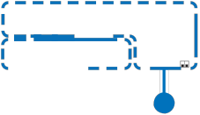

2 POWER: Press this button to power ON the device or set it to standby mode.
3 MENU: Press this button to bring up the OSD menu on screen.
4 -/+ Buttons: Press these buttons to scroll down/up the OSD
selections.
5 CHANNEL INPUT 1~4: Press these buttons to rotate HDMI 1~4 input source on each channel to be display on screen. All channels can select the same input or each channel a different input.
6 WINDOW A~H: Press these hot keys to select the screen setting where A~D are display a full screen of each channel and E~H are a different combination of a full screen setting with all 4 channels. Windows A~D's channel input selection is corresponding to
channel input no. 1~4. That is, to change window A's input channel must press channel input 1's button. Channel input 2~4's button
will not activate under window A's selection. Windows E~H's size are adjustable through the OSD menu setting and only window G is PIP(Picture in Picture) where E,F & H are POP (Picture out Of picture) settings.
Under window E~H when the size setting is overlapping one another, channel display sequence is CH4 > CH3 > CH2 >CH1.
That is, CH4 will cover CH3 and CH3 will cover CH2 and so on.
Under some dislay the borderline may have interference, adjusting
display's motion setting may resolve the interference issue.

6.2 Rear Panel

HDMI IN

4 3 2 1
HDMI OUT
CONTROL

USB SERVICE ONLY
RS232 DC 12V

1 2 3 4 5 6

1 HDMI IN: Connect with source equipments such as DVD/Blu-ray players and or PC/NB devices.
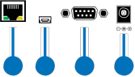

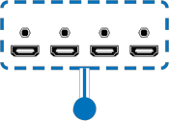

2 HDMI OUT: Connect with HD TV/monitor for output image display
at 1080p.
3 CONTROL: Connect to an active network for Telnet control.
4 USB SERVICE ONLY: This slot is reserved for logo file upload and
factory use only.
Logo file requirements: bmp file with color 256 only with size up to
512x512.
Upload procedure: Enter into OSD menu→IO Setup→LOGO Setting→Load New LOGO, now both Window A and CH 1's button LED will illuminate, plug this USB port to your PC/Laptop and wait for USB window to pop up.
Drag and load the logo file into the USB window or into "COPY LOGO" and upload will be automatically proceed. Wait for 1~2 minute the device will reboot itself and the upload is succed.
5 RS-232: Connect from PC/NB with D-Sub 15pin cable for RS-232 command sending.
6 DC 12V: Plug the 12V DC power supply into the unit and connect the adaptor to an AC outlet.

6.3 Remote Control
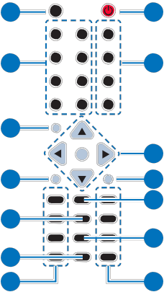

2
1 Power: Press this button to switch on the
device or press it again to set it to standby mode. 4
2 Info: Press this button to show the device’s

Info Power
1
WA WE CH 1

WB WF CH 2
3
WC WG CH 3

WD WH CH 4

firmware version. 5
3 Input CH 1~4: Press these buttons to rotate
HDMI 1~4 input source on each channel to 8
Mute

Exit
Input

OK 6
Menu
7

be display on screen
4 WA~WH: Press these hot keys to select the 10
screen setting where WA~WD are display 12
a full screen of each channel and WE~WH
13
are a different combination of a full screen
setting with all 4 channels.
5 Mute: Press this button to mute the audio
from HDMI output port.
Audio 1 Fade In-Out FAV. 1

Audio 2 Chromakey FAV. 2
9

Audio 3 Mirror FAV. 3
11

Audio 4 Rotation FAV. 4

14
CR-124

6 ▲▼►◄ & OK Buttons: Press this buttons to scroll through the OSD
selection and press OK to enter and confirm the setting.
7 Menu: Press this button to enter into the OSD menu.
8 Exit: Press this button to exit the OSD menu or the OSD settings.
9 FAV. 1~4: Press these buttons to bring up the customized screen
settings.

10 Fade-In-Out*: Press this button to switch on or off the Fade-in-out function.
11 Chromakey*: Press this button to enter into Chroma function where
CH 1 is the background and CH 2 is the top image.
12 Mirror*: Press this button to display the screen in mirror image.
13 Rotation*: Press this button to rotate the image 90˚ left and right or
180˚ upside down.

14 Audio 1~4: Press these buttons to select audio from HDMI input source 1~4.
* Functions only work under Window A to D. The system will force
to switch to Window A when operate under Window E~H.

6.4 RS-232 Protocols

►
HDMI SCALER
Pin | Assignment
1 | NC
2 | Tx
3 | Rx
4 | NC
5 | GND
6 | NC
7 | NC
8 | NC
9 | NC

REMOTE CONTROL (PC)
Pin | Assignment
1 | NC
2 | Rx
3 | Tx
4 | NC
5 | GND
6 | NC
7 | NC
8 | NC
9 | NC

◄

Baud Rate: 115200bps
Data Bit: 8 bits
Parity: None
Flow Control: None
Stop Bit: 1

6.5 OSD Menu

MAIN MENU | 1ST LAYER | 2ND LAYER | 3RD LAYER
I/O Setup | Output  Resolution | 480P, 579P, 720P50/60,  1080P24/25/30/50/60,  1024x768, 1280x800,  1280x1024, 1366x768,  1440x900, 1600x900,  1600x1200, 1680x1050,  1920x1200, NATIVE
 |  | Menu Exit
 | Output  Windows | Window A
 |  | Window B
 |  | Window C
 |  | Window D
 |  | Window E
 |  | Window F
 |  | Window G
 |  | Window H
 |  | Win Fav 1
 |  | Win Fav 2
 |  | Win Fav 3
 |  | Win Fav 4
 |  | Menu Exit
 | OSD Settings | Info Display | On/Off
 |  | H Offset | 0~20 (5)
 |  | V Offset | 0~20 (5)
 |  | Timeout | Off~50 (10)
 |  | Transparent | 0~10 (2)
 |  | Menu Exit
 |  | Logo Display | On/Off
 |  | Logo H-Pos | 0~74 (73)

MAIN MENU | 1ST LAYER | 2ND LAYER | 3RD LAYER
 | Logo  Settings | Logo V-Pos | 0~68 (6)
 |  | Load Def Logo | On/Off
 |  | Load New Logo | On/Off
 |  | Menu Exit
 | Menu Exit
Image  Adjust | Brightness  Adjust | CH1 | 0~100 (50)
 |  | CH2 | 0~100 (50)
 |  | CH3 | 0~100 (50)
 |  | CH4 | 0~100 (50)
 |  | Value Reset
 |  | Menu Exit
 | Contrast  Adjust | CH1 | 0~100 (50)
 |  | CH2 | 0~100 (50)
 |  | CH3 | 0~100 (50)
 |  | CH4 | 0~100 (50)
 |  | Value Reset
 |  | Menu Exit
 | Hue Adjust | CH1 | 0~100 (50)
 |  | CH2 | 0~100 (50)
 |  | CH3 | 0~100 (50)
 |  | CH4 | 0~100 (50)
 |  | Value Reset
 |  | Menu Exit
 | Saturation | CH1 | 0~100 (50)
 |  | CH2 | 0~100 (50)
 |  | CH3 | 0~100 (50)
 |  | CH4 | 0~100 (50)
 |  | Value Reset
 |  | Menu Exit

MAIN MENU | 1ST LAYER | 2ND LAYER | 3RD LAYER
 | Image Still  Adjust | CH1 | On/Off
 |  | CH2 | On/Off
 |  | CH3 | On/Off
 |  | CH4 | On/Off
 |  | All Channel | On/Off
 |  | Menu Exit
 | Image  Swap | CH 1 CH 2 Swap.
 |  | CH 1 CH 3 Swap.
 |  | CH 1 CH 4 Swap.
 |  | CH 2 CH 3 Swap.
 |  | CH 2 CH 4 Swap.
 |  | CH 3 CH 4 Swap.
Window  Setup | Channel  1/2/3/4  Select | Size Wxxx Hxxx | Width Unit
 |  |  | Width Ten
 |  |  | Width Hundred
 |  |  | Height Unit
 |  |  | Height Ten
 |  |  | Height Hundred
 |  |  | Value Rest
 |  |  | Menu Exit
 |  | Position Wxxx Hxxx | Width Unit
 |  |  | Width Ten
 |  |  | Width Hundred
 |  |  | Height Unit
 |  |  | Height Ten
 |  |  | Height Hundred
 |  |  | Value Rest
 |  |  | Menu Exit
 |  | Image Output | On/Off

MAIN MENU | 1ST LAYER | 2ND LAYER | 3RD LAYER
 |  | Priority | 1~4
 |  | Window Reset
 |  | Menu Exit
 | Label Select | Video 1 | Rename up to 9  characters
 |  | Video 2 | Rename up to 9  characters
 |  | Video 3 | Rename up to 9  characters
 |  | Video 4 | Rename up to 9  characters
 |  | Menu Exit
 | Favours  Store | FAV 1 Store | On/Off
 |  | FAV 2 Store | On/Off
 |  | FAV 3 Store | On/Off
 |  | FAV 4 Store | On/Off
 |  | Menu Exit
 | Menu Exit
Window  Convert | Channel  1/2/3/4  Convert | Mirror | On/Off
 |  | Fade In-Out | Off/1.0/1.1/1.2/1.3/1.4/  1.5/1.6/1.7/1.8/1.9/2.0/  2.1/2.2/2.3/2.4/2.5/2.6/  2.7/2.8/2.9/3.0
 |  | Rotation | L90/R90/180/Off
 |  | Window Reset
 |  | Menu Exit

MAIN MENU | 1ST LAYER | 2ND LAYER | 3RD LAYER
Chromakey  Setup* | User 1 | Minimum for R/G/B | 000~255 (233)
 |  | Maximum for R/G/B | 222~255(255)
 | User 2 | Minimum for R/G/B | 000~255 (0)
 |  | Maximum for R/G/B | 222~255(255)
 | White | Minimum for R/G/B | 000~255 (233)
 |  | Maximum for R/G/B | 222~255(255)
 | Yellow | Minimum for R/G/B | 000~255 (233/233/0)
 |  | Maximum for R/G/B | 222~255(255/255/16)
 | Cyan | Minimum for R/G/B | 000~255 (233/0/233)
 |  | Maximum for R/G/B | 222~255(255/16/255)
 | Green | Minimum for R/G/B | 000~255 (233/0/0)
 |  | Maximum for R/G/B | 222~255(255/16/16)
 | Magenta | Minimum for R/G/B | 000~255 (0/233/233)
 |  | Maximum for R/G/B | 222~255(16/255/255)
 | Red | Minimum for R/G/B | 000~255 (0/233/0)
 |  | Maximum for R/G/B | 222~255(0/233/0)
 | Blue | Minimum for R/G/B | 000~255 (0/0/232)
 |  | Maximum for R/G/B | 222~255(16/16/255)
 | Black | Minimum for R/G/B | 000~255 (0)
 |  | Maximum for R/G/B | 222~255(16)
 | Switch | On/Off
 | Exit
 | IP Mode | Static/DHCP
 | Static Set | IP/Mask/Gate
 | Byte1 High | 192
 | Byte2 | 168
 | Byte3 | 1
 | Byte4 Low | 50

MAIN MENU | 1ST LAYER | 2ND LAYER | 3RD LAYER
Ethernet  Setup | Time Out | OFF/10/20/30/40/50/60 min
 | Re-Link | No/Yes
 | Exit
 | Static/DHCP  IP | LINKED/NOT LINKED
 | IP | IP/Mask/Gate
 | Mask | xxx. xxx. xxx. xxx
 | Gate | xxx. xxx. xxx. xxx
 | Mac | xxx. xxx. xxx. xxx
Sink HDMI/
DVI
Audio Setup | Audio  Source | Mute/CH1/2/3/4
Sys Reset | On/Off
Information | Screen  HDMI
Native
xxxxxx
F/W version
vx.xx
 | F/W Upgrade
 | Menu Exit
Menu Exit
Note: BoldItalic fonts and ( ) figures are factory defualt setting figures.
* Chromakey Setup works only under CH1& CH2 where CH1 is the background and CH2 is the top layer. This special function is designed for picture overlap video such as news reporter,
weather forecast or educational video taping. CH2 the top layer's background color is usually a single color which can be easy for remove. RGB's setting is for CH2 video where the minimum setting

figures cannot be greater than the maximum figures and the maximum figures cannot be lower than the minimum setting figures. When input 1 or 2 has no source connection a warning message will appear on OSD.

6.6 RS-232 and Telnet Commands

COMMAND DESCRIPTION |  | PARAMETER
? | PRINTS ALL AVAILABLE RS-232/TELNET COMMANDS TO THE SCREEN
HELP | PRINTS ALL AVAILABLE RS-232/TELNET COMMANDS TO THE SCREEN!
SPOW 0/1 | SET THE UNIT POWER  ON/OFF | 0=OFF,1=ON
RPOW | SHOW CURRENT POWER STATE
SRES 0~18 | SET OUTPUT RESOLUTOIN | (0) 480p 60Hz, (1) 576p  50Hz,(2) 720p 50Hz, (3)  720p 60Hz, (4) 1080p  24Hz, (5) 1080p 25Hz, (6)  1080p 30Hz, (7) 1080p  50Hz, (8) 1080p 60Hz, (9) 1024x768 60Hz, (10) 1280x800 60Hz, (11) 1280x1024 60Hz, (12) 1366x768 60Hz, (13) 1440x900 60Hz, (14) 1600x900 60Hz, (15)1600x1200 60Hz, (16) 1680x1050 60Hz, (17)1920x1200 60Hz, (18) Native
RRES | SHOW CURRENT OUTPUT RESOLUTION
SIOSDD 0/1 | ENABLE/DISABLE ONSCREEN INFORMATION DISPLAY | 0=OFF,1=ON (0)

COMMAND DESCRIPTION |  | PARAMETER
RIOSDD | SHOW INFORMATION OSD DISPLAY CURRENT STATE
SOSDH 0~20 | SET OSD HORIZONTAL  POSITION | 0~20 (5)
ROSDH | SHOW OSD HORIZONTAL POSITION CURRENT
SOSDV 0~20 | SET OSD VERTICAL  POSITION | 0~20 (5)
ROSDV | SHOW OSD VERTICAL POSITION CURRENT
SOSDT  0, 5~50 | SET OSD DISPLAY TIME | 0=OSD OFF  OSDTIME (5~50 sec) DEFAULT=10sec
ROSDT | SHOW OSD DISPLAY CURRENT TIME
SOSDG 0~10 | SET OSD TRANSPARENT VALUE | 0~10 (5)
ROSDG | SHOW OSD TRANSPARENT CURRENT VALUE
SBRI N M | SET BRIGHTNESS VALUE FOR INPUT CHANNEL | N=0/All, 1~4/CHANNEL M=0~100 (50)
RBRI | SHOW BRIGHTNESS CURRENT VALUE FOR INPUT CHANNEL | 0=All, 1~4
SCON N M | SET CONTRAST VALUE FOR INPUT CHANNEL | N=0/All, 1~4/CHANNEL M=0~100 (50)
RCON | SHOW CONTRAST CURRENT VALUE!! | 0=All, 1~4

COMMAND DESCRIPTION |  | PARAMETER
SSAT N M | SET SATURTATION VALUE FOR INPUT CHANNEL!! | N=0/All, 1~4/CHANNEL M=0~100 (50)
RSAT | SHOW SATURTATION CURRENT VALUE | 0=All, 1~4
SHUE N M | SET HUE VALUE FOR INPUT CHANNEL | N=0/All, 1~4/CHANNEL M=0~100 (50)
RHUE | SHOW HUE CURRENT VALUE | 0=All, 1~4
SSTILL N M | SET IMAGE STILL | N=0/All, 1~4/CHANNEL  M=0/OFF, 1/ON(0)
RSTILL | SHOW IMAGE CURRENT  STILL STATUS | 0=All, 1~4
SSWAP (0~5) | SET OUTPUT IMAGE SWAP | 0= CH1 CH2 SWAP.  1= CH1 CH3 SWAP.  2= CH1 CH4 SWAP.  3= CH2 CH3 SWAP.  4= CH2 CH4 SWAP.  5= CH3 CH4 SWAP
RSWAP | SHOW IMAGE CURRENT INPUT SOURCE | 0=CH1 CH2 CURRENT INPUT SOURCE  1=CH1 CH3 CURRENT INPUT SOURCE  2=CH1 CH4 CURRENT INPUT SOURCE  3=CH2 CH3 CURRENT INPUT SOURCE  4=CH2 CH4 CURRENT INPUT SOURCE  5=CH3 CH4 CURRENT INPUT SOURCE

COMMAND DESCRIPTION |  | PARAMETER
SPIRE | RESET BRIGHTNESS, CONTRAST, SATURTATION, HUE. ALL CHANNEL VALUE TO DEFAULE
SIMRE 1~4 | RESET BRIGHTNESS or CONTRAST or SATURTATION or HUE, VALUE TO DEFAULE | 1=BRIGHTNESS,  2=CONTRAST,  3=SATURTATION, 4=HUE
SHSIZE N M | SET IMAGE HORIZONTAL SIZE | N=1~4  M=0~X HORZONTAL SIZE FOR CURRENT RESOLUTION
RHSIZE | SHOW IMAGE HORIZONTAL SIZE CURRENT VALUE | 1~4 CHANNEL HORIZONTAL SIZE
SVSIZE N M | SET IMAGE VERTICAL SIZE | N=1~4  M=0~X VERTICAL PIXEL FOR CURRENT RESOLUTION
RVSIZE | SHOW IMAGE VERTICAL SIZE CURRENT VALUE | 1~4 CHANNEL VERTICAL SIZE
SHPOS N M | SET HORIZONTAL POSITION OF SPECIFIED CHANNEL!! | N=1~4  M=0~X HORZONTAL PIXEL FOR CURRENT RESOLUTION
RHPOS | SHOW IMAGE HORIZONTAL POSITION CURRENT VALUE!! | 1~4 CHANNEL HORIZONTAL POSITION
SVPOS N M | SET VERTICAL POSITION OF SPECIFIED CHANNEL!! | N=1~4  M=0~X VERTICAL PIXEL FOR CURRENT RESOLUTION

COMMAND DESCRIPTION |  | PARAMETER
RVPOS | SHOW IMAGE VERTICAL POSITION CURRENT VALUE!! | 1~4 CHANNEL VERTICAL POSITION
SIMAGE N M | SET OUTPUT CHANNEL IMAGE ON/OFF!! | N= 1~4  M=0/OFF, 1/ON
RIMAGE | SHOW OUTPUT CHANNEL IMAGE CURRENT | (0)=ALL CHANNEL, (1~4)=CHANNEL 1~4
SPRI N M | SET WINDOWS PRIORITY | N= CHANNEL 1~4  M= PRIORITY 1~4
RPRI | SHOW WINDOWS PRIORITY | 0=ALL CHANNEL,  1~4=CHANNEL 1~4
SLABEL N M | ASSIGN A PRESET NAME | N= CHANNEL 1~4  M= A~Z/0~9….
RLABEL | SHOW PRESET NAME TO SCREEN!! | 0=ALL CHANNEL,  1~4=CHANNEL 1~4
SSTORE 1~4 | SAVE THE CURRENT WINDOW TO FAV1~FAV4. | 1~4= FAV1~FAV4
SRECALL 1~12 | SET A OUTPUT WINDOWS TO WINDOWS A~WINDOWS FAV4. | (1)WA, (2)WB, (3)WC, (4)WD, (5)WE, (6)WF, (7) WG, (8)WH, (9) FAV1, (10)FAV2, (11)FAV3, (12)FAV4.
SMIRROR 0/1 | SET ENABLE/DISABLE MIRROR EFFECT | 0=OFF,1=ON
RMIRROR | SHOW MIRROR CURRENT TO SCREEN!!

COMMAND DESCRIPTION |  | PARAMETER
SFADE 0~21 | SET FADE IN-OUT TIME | (0) OFF, (1) 1.0 s, (2) 1.1 s, (3) 1.2 s, (4) 1.3 s, (5)  1.4 s, (6) 1.5 s, (7) 1.6 s, (8) 1.7 s, (9) 1.8 s, (10)  1.9 s, (11) 2.0 s, (12) 2.1 s, (13) 2.2 s, (14) 2.3 s, (15) 2.4 s, (16) 2.5 s, (17)  2.6 s, (18) 2.7 s,(19) 2.8  s, (20) 2.9 s, (21) 3.0 s (0)
RFADE | SHOW FADE IN-OUT CURRENT TO SCREEN!!
SROTATE 0~3 | SET VIDEO ROTATION VIDEO TO PRESET POSITIONS | 0=ROTATE OFF, 1=R90,  2=180 3=L90(0)
RROTATE | SHOW VIDEO ROTATION CURRENT TO SCREEN
SCHRKS 0~9 | SET CHROMAY KEY COLOR FOR CHROMA KEY!! | (0) USER1,(1)USER2,(2) White,(3)Yellow,(4) Cyan,(5) Green, (6) Magenta,(7) Red,(8) Blue,(9)Black(0)
RCHRKS | SHOW CHROMAKEY KEY COLOR CURRENT TO SCREEN!!
SCHRC N M | SET THE R,G,B COLOR RANGE FOR THE CHROMA KEY | N=0~11, (0)USER1 G MAX, (1)USER1 G MIN, (2)USER1 R MAX, (3) USER1 R MIN (4)USER1 B MAX, (5)USER2 B MIN, (6)USER2 G MAX, (7) USER2 G MIN, (8)USER2  B MAX, (9)USER2 B MIN (10)USER2 R MAX, (11) USER2 R MIN  M= VALUE 0~255

COMMAND DESCRIPTION |  | PARAMETER
RCHRC 0~9 | SHOW CHROMAKEY CURRENT TO SCREEN | (0)USER1,(1)USER2,(2) White,(3)Yellow,(4) Cyan,(5) Green, (6) Magenta,(7) Red,(8) Blue,(9)Black
SCHRSW 0/1 | SET ENABLE/DISABLE CHROMAKEY EFFECT | 0=OFF, 1=ON (0)
RCHRSW | SHOW CHROMAKEY EFFECT CURRENT TO SCREEN
SIPM 0/1 | SET IP MODE TO DHCP  OR STATI | 0=0DHCP, 1=STATIC (1)
RIPM | SHOW CURRENT IP MODE TO SCREEN
SIPADD N | SET STATIC IP ADDRESS | N=0~255
RIPADD | SHOW STATIC CURRENT IP ADDRESS TO SCREEN
SMAADD N | SET STATIC SUBNET ADDRESS | N=0~255
RMAADD | SHOW STATIC CURRENT SUBNET ADDRESS TO SCREEN
SGAADD N | SET STATIC GATEWAY ADDRESS | N=0~255
RGAADD | SHOW STATIC CURRENT GATEWAY ADDRESS TO SCREEN

COMMAND DESCRIPTION |  | PARAMETER
SETHT 0~6 | SET ETHERNET TIMEOUT!! | (0)OFF, (1)10 MINUTE, (2)20 MINUTE, (3)30  MINUTE, (4)40 MINUTE, (5)50 MINUTE, (6)60  MINUTE.  (0)
RETHT | SHOW ETHERNET TIMEOUT CURRENT TO SCREEN
RELINK | RELINK THE UNIT IN 2  SECONDS
SMAC 0~9, A~F | SET MAC ADDRESS!! | 0~9, A~F
RMAC | SHOW CURRENT MAC ADDRESS TO SCREEN
IPCONFIG | SHOW ETHERNET ADDRESS TO SCREEN
DEFAULT | RESET THE UNIT TO FACTORY DEFAULTS
SVICH N M | SET OUTPUT VIDEO CHANNEL TO SPECIFIED SOURCE!! | N=0~4, 0=ALL CHANNEL, 1~4=OUTPUT CHANNEL  M=1~4 VIDEO SOUREC
RVICH | SHOW OUTPUT CHANNEL THE VIDEO SOUREC
SMUTE 0/1 | SET MUTE AUDIO | 0=MUTE, 1= UNMUTED  (1)
RMUTE | SHOW CURRENT MUTE TO SCREEN!!
SAUDIO 1~4 | SET OUTPUT AUDIO TO SPECIFIED SOURCE | 1~4=INPUT AUDIO

COMMAND DESCRIPTION |  | PARAMETER
RAUDIO | SHOW OUTPUT AUDIO SOURCE TO SCREEN
SCHRE 0~4 | RESET THE WINDOWS E ~ WINDOWS FAV4  CH1~CH4 SETTINGS TO FACTORY DEFAULTS | 0=RESET ALL CHANNEL,  1~4=RESET CHANNEL  1~4
SWICORE | RESET THE WINDOWS A  ~ WINDOWS D SETTINGS TO FACTORY DEFAULTS
RBIOS | SHOW BIOS VERSION TO SCREEN
RLOGOD | SHOW DISPLAY LOGO CURRENT STATE
SLOGOD 0/1 | ENABLE/DISABLE DISPLAY LOGO | 0=OFF, 1=ON
RLOGOH | SHOW LOGO HORIZONTAL POSITION CURRENT
SLOGOH N | SET LOGO HORIZONTAL  POSITION | N=HORZONTAL PIXEL FOR CURRENT RESOLUTION
RLOGOV | SHOW LOGO VERTICAL POSITION CURRENT
SLOGOV N | SET LOGO VERTICAL  POSITION | N=VERTICAL PIXEL FOR CURRENT RESOLUTION
SDEFLOGO | LOAD DEFAULT LOGO
SNEWLOGO | LOAD NEW LOGO

6.7 Telnet Control

Before attempting to use the telnet control, please ensure that both the Scaler (via the ‘CONTROL’ port) and the PC/Laptop are connected to the active networks.
To access the telnet control in Windows 7, click on the ‘Start’ menu and type “cmd” in the Search field then press enter Under Windows XP go to the ‘Start’ menu and click on “Run”, type “cmd” with then press enter.
Under Mac OS X, go to Go→Applications→Utilities→Terminal See
below for reference.

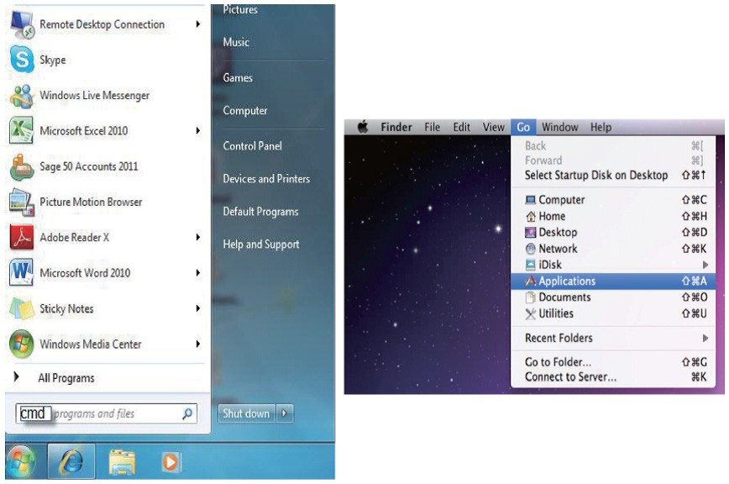

Once in the command line interface (CLI) type “telnet”, then the IP
address of the unit and hit enter.
Note: The IP address of the Scaler can be found under Ethernet Setup on the device’s OSD menu.
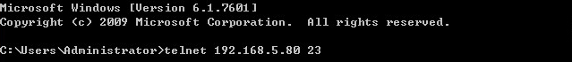

This will bring us into the device which we wish to control. Type “?” to lists all the available commands.

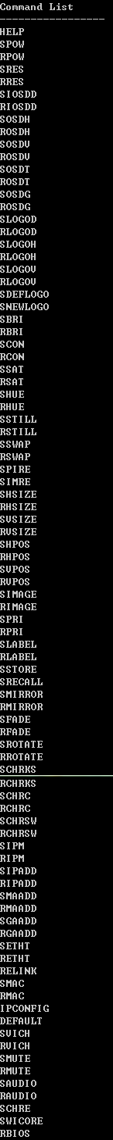

Type “IPCONFIG” To show all IP configurations. To reset the IP, type “IPMODE” to set static IP/DHCP (For a full list of commands, see Section 6.6).
Note: All the commands will be not executed unless followed by a carriage return. Commands are case-insensitive. If the IP is changed then the IP Address required for Telnet access will also need to be change accordingly. A power relink is also required for every IP change.

6.8 WebGUI Control

On a PC/Laptop that is connected to an active network as the
Scaler, open a web browser and type device’s IP address on the web address entry bar. The browser will display the device’s Image Adjust, Output Resolution, and ... etc.
Click on the ‘Image Adjust’ tab to control power, Window Mode and the windows settings.
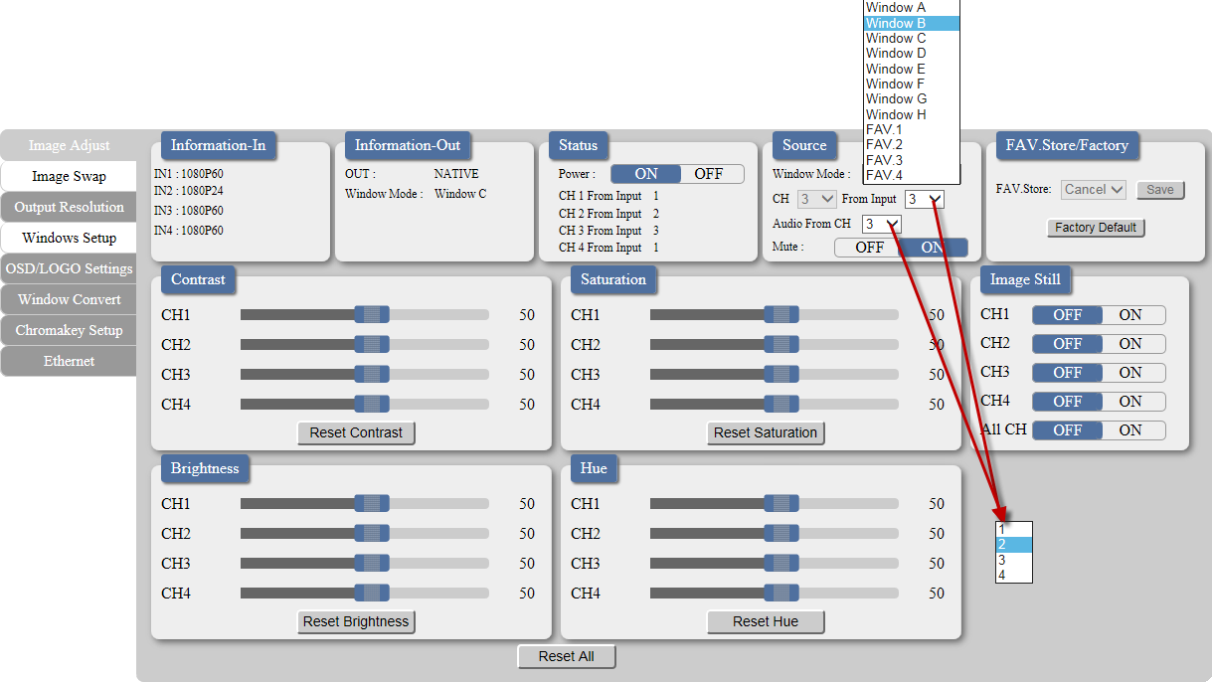

Click on 'Image Swap' to swap output channel's image display
instantly.
Note: This function is only available under window E~H.
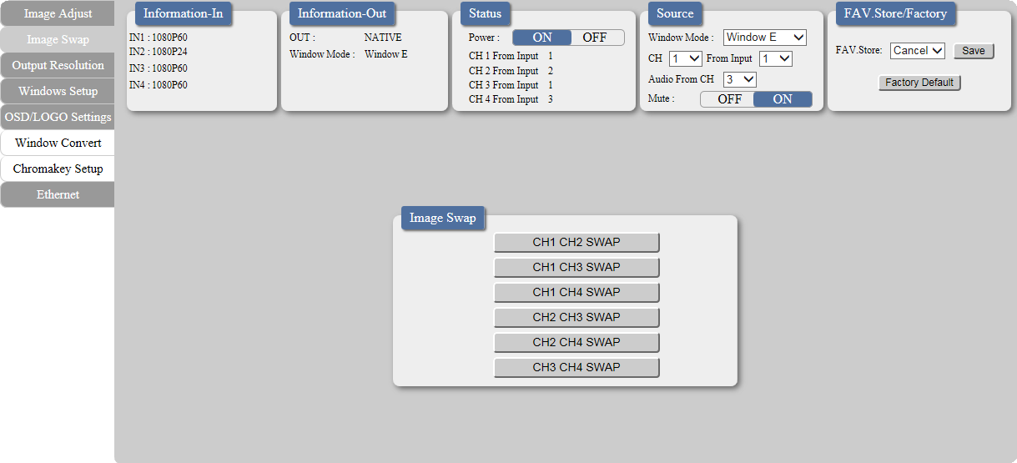

Click on the ‘Output Resolution’ tab to set the output display resolution.
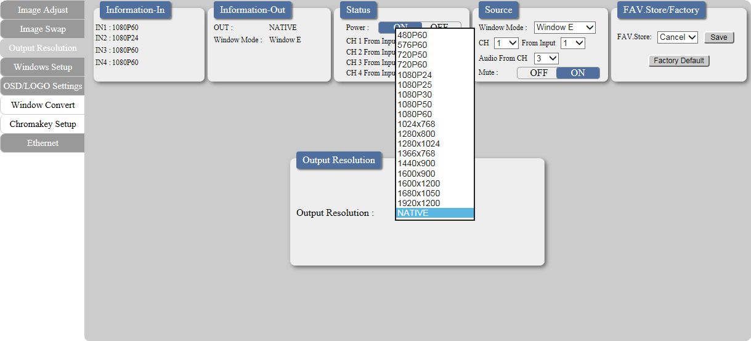

Clicking on the ‘Windows Setup’ tab to set the output display fomate.
Note: This function is only available under window E~H.
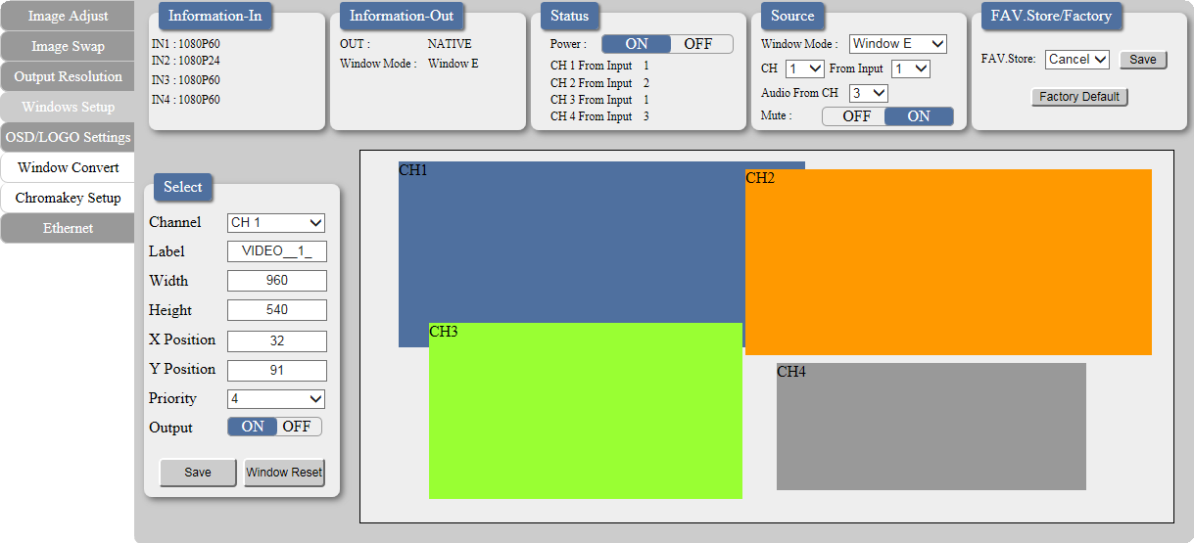

Clicking on the ‘OSD/LOGO Settings’ tab to set the OSD & LOGO's function and position. Load and upload logo can also be done under this page. Upload procedure please refers to section 6.2 USB SERVICE ONLY.
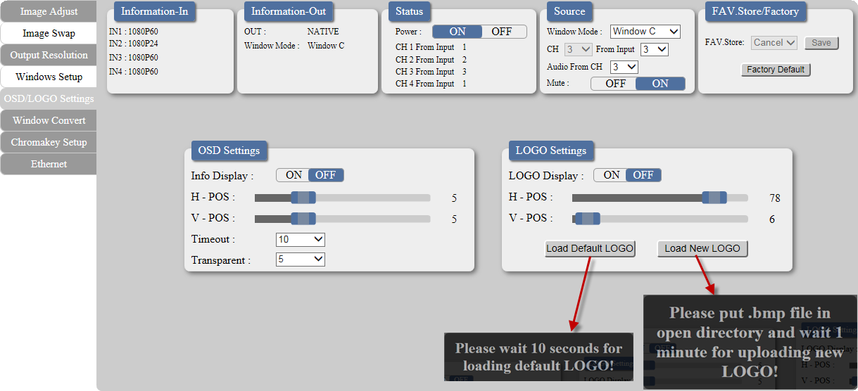

Clicking on the ‘Window Convert’ tab to set the output display angle.
Note: This function is only available under window A~D.
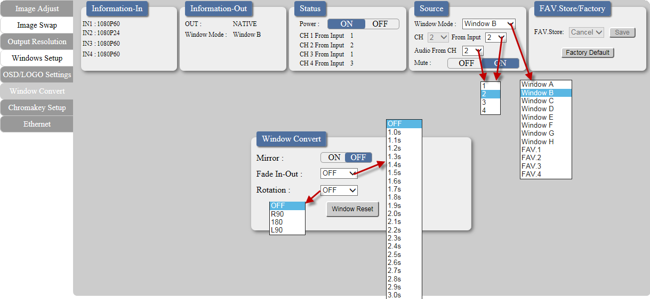

Clicking on the ‘Chromakey Setup’ tab to set the output display color.
Note: This function is only available under window A~D.
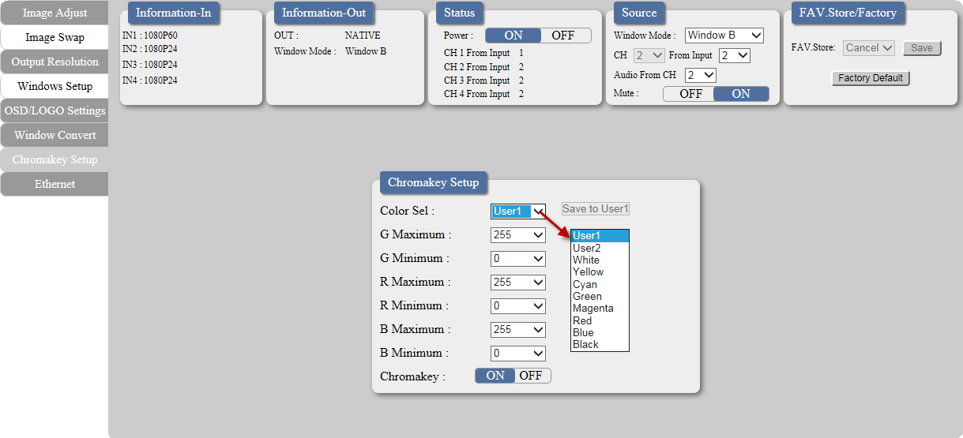

Clicking on the ‘Ethernet’ tab to reset the IP configuration. The system will ask for a reboot of the device every time when any of the settings is changed. The IP address needed to access the WebGUI control will also need to be changed accordingly on the web address entry bar.
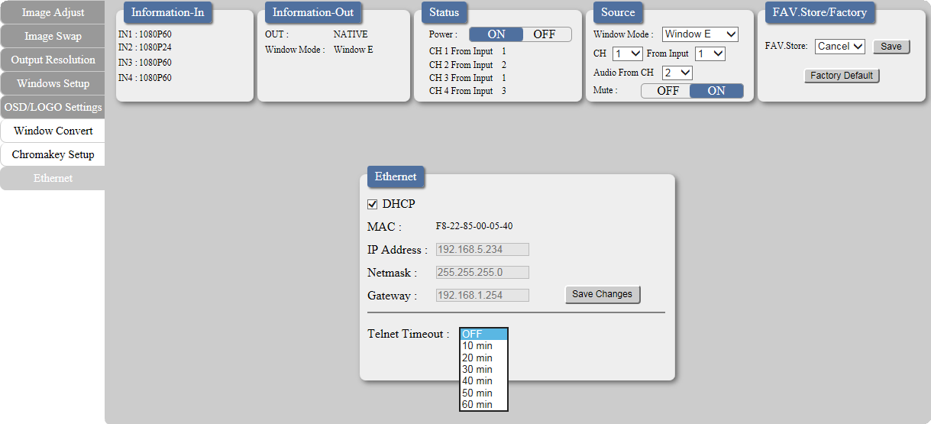

7. CONNECTION DIAGRAM

HDMI Camera Blu-ray Player Set-top Box

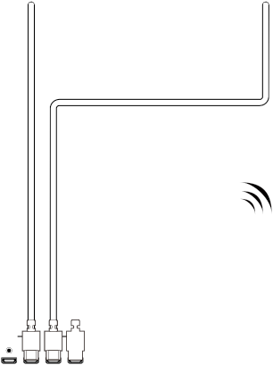

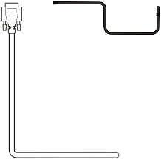

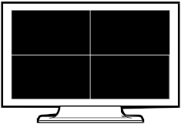

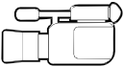

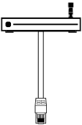

Games Console

HDMI Inputs

4 3 2 1

Router

Smartphone or Tablet Device

HDMI OUT
HDMI
3
IN
2
1
4

CONTROL

USB SERVICE ONLY

RS232 DC 12V
Power
Supply

HDMI Output
RS-232

RS-232 Enabled PC/Laptop or Control System

HDTV

Screen Configurations:

1 2 2
3 1
3 4 4

1 1 2

2 3 4 3 4

Window E (POP)
Window F (POP)
Window G (PIP)
Window H (POP)

8. SPECIFICATIONS

Video Bandwidth | 225MHz/6.75Gbps
Input Ports | 4 x HDMI
Output Port | 1 x HDMI
Supports Input Resolution | PC: VGA~WUXGA, HD: 480i~1080p
Supports Output Resolution | 1080p@60
HDMI Input Cable Distance | Up to 15M/1080p@12 bits
HDMI Output Cable Distance | Up to 15M/1080p@8 bits
Supports Sampling Rate | 32~192kHz
ESD Protection | Human body model:  ±8kV (air-gap discharge)  ±4kV (contact-gap discharge)
Power Supply | 12V/3A DC (US/EU standards, CE/FCC/UL  certified)
Dimensions | 436mm(W) x 247mm(D) x 44mm(H)
Weight | 2200 g
Chassis Material | Aluminum
Silkscreen Color | Black
Operating Temperature | 0 ˚C ~ 40 ˚C / 32 ˚F ~ 104 ˚F
Storage Temperature | −20˚C ~ 60 ˚C / −4 ˚F ~ 140 ˚F
Relative Humidity | 20 ~ 90 % RH (non-condensing)
Power Consumption | 18 W

HDMI SUPPORTED RESOLUTIONS INPUT OUTPUT
640x480@60,72,75,85 | ✓
800x600@56,60,72,75,85 | ✓
1024x768@60,70,75,85 | ✓ | V@60
1360x768@60 | ✓
1280x768@60,75 | ✓
1280x800@60 |  | ✓
1280x1024@60,75 | ✓ | V@60
1366x768@60 | ✓ | ✓
1440x900@60 |  | ✓
1600x900@60 |  | ✓
1600x1200@60 | ✓ | ✓
1680x1050@60
1920x1200@60 | ✓
480i60 | ✓
576i50 | ✓
480p60 | ✓ | ✓
576p50 | ✓ | ✓
720p50 | ✓ | ✓
720p60 | ✓ | ✓
1080i50 | ✓
1080i60 | ✓
1080p24 | ✓ | ✓
1080p25 |  | ✓
1080p30 |  | ✓
1080p50 | ✓ | ✓
1080p60 | ✓ | ✓

