I-4 and Q-8 User Guide

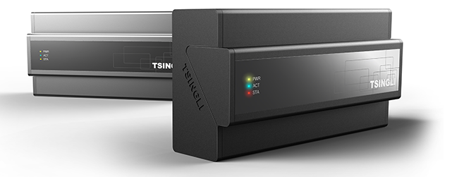

TABLE OF CONTENTS

1. Connecting to the I-4 from PC 2
2. IR Learning 3
3. Saving the IR File 4
4. Connecting the I-4 to the Q-8 5
5. Connecting by UDP 5
6. Connecting by UCLink 7
7. I-4 Specifications 8
8. Q-8 Central Controller output ports 8
9. Installation Diagram Q-8 Stand Alone 11
10. Mounting the I-4 and Q-8 11
11. Q-8 Parameters 13
12. Q-8 Specs 15

Connecting to the I-4 from PC

Set your PC’s IP address to something compatible with the I-4. The default IP address of the I-4 is 192.168.0.160 so you could set the IP address of your PC’s Ethernet adapter to 192.168.0.100, for example.

Connect your PC to I-4 using a standard Ethernet cable. Open your web browser and enter 192.168.0.160 into the address bar to pull up the web interface. Click English upper right.

(You can change the IP address of the I-4 in the Web Interface. You can also reset to default by pressing the RST button and holding until the STA light flashes 5 times. The default user name is admin and password admin.)
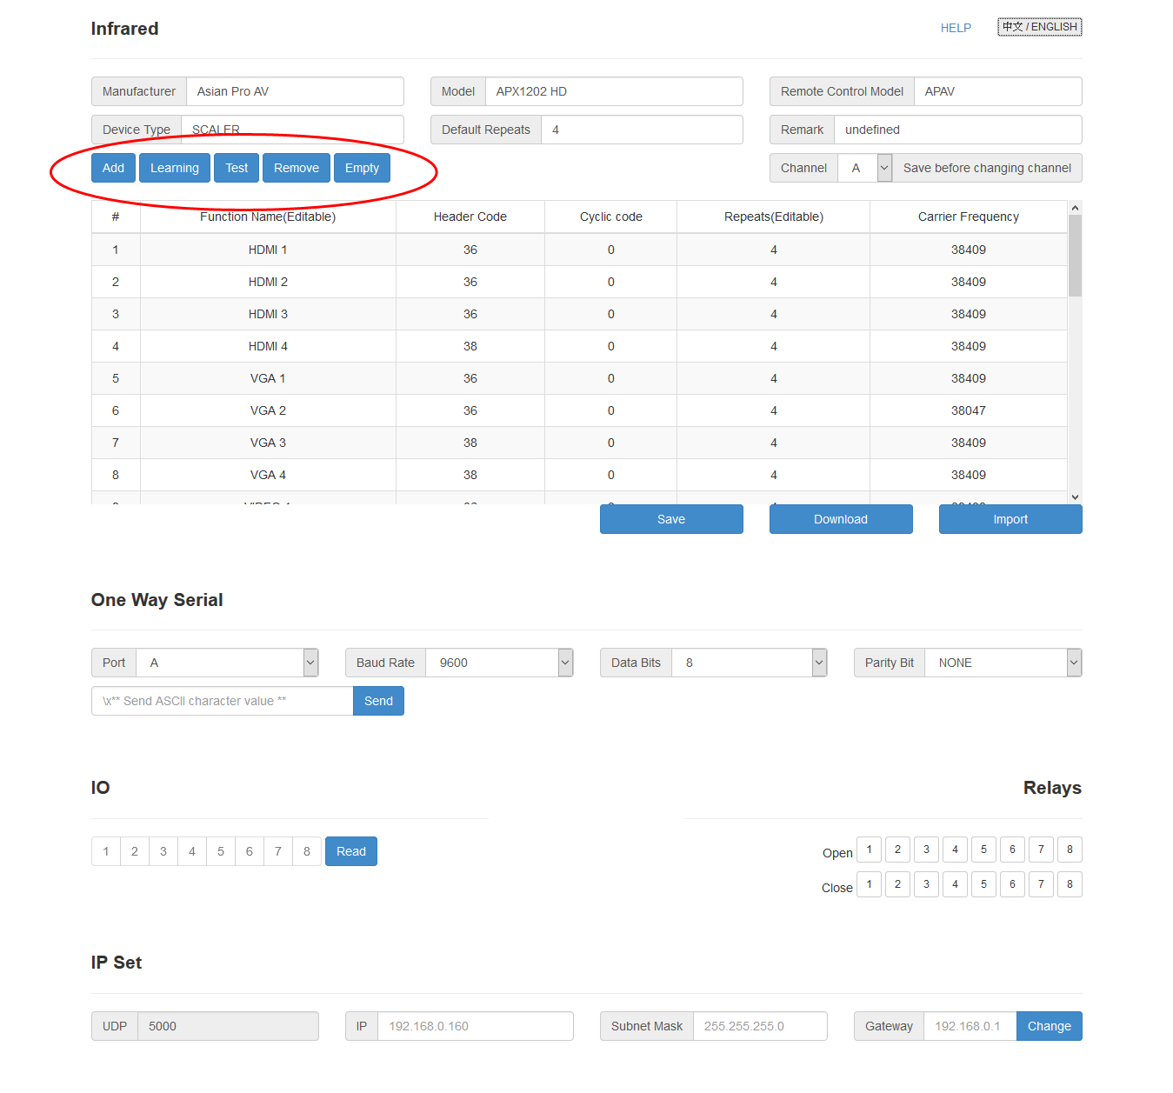

IR Learning

Click the Add button (see red circle above) and enter the name of the command you wish to learn. In this case we’re learning the IR commands for the APX1202 HD video scaler starting with switching to the HDMI 1 input. Press the Learning button to put the I-4 into “Learning Mode”. Hold your handheld IR remote control a few inches from the I-4 IR sensor (see picture below). Press the button you wish to learn quickly then release. Repeat for every command you wish to learn. Pressing the Test button will send the learned command out the IR port and the IR sensor simultaneously. This allows you to verify if the command was learned correctly either by attaching an IR emitter from the IR output port to the device’s IR sensor or by aiming the I-4’s IR sensor at the device’s IR sensor.

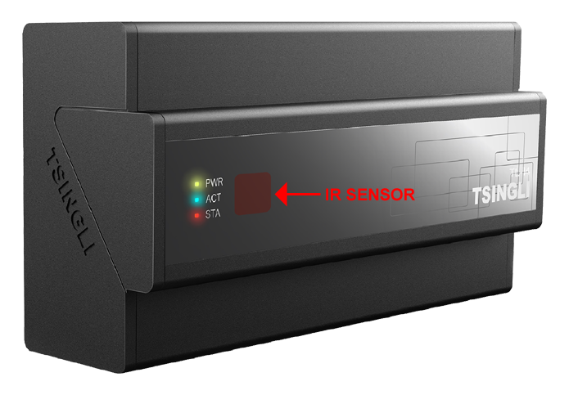

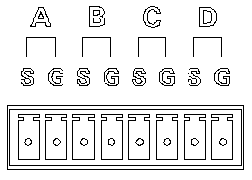
Infrared Output Connecting Block

Saving the IR File

Pressing the Save button will save the IR file to the I-4. Pressing the Download button will save the file as a .sir file type to store in your Logic Master IR library.

Connecting the I-4 to the Q-8

The I-4 can be connected to the Q-8 either by UDP or UCLink

Connecting by UDP

Save your work to the I-4 using by pressing the Save button.

Connect the I-4 directly to the Q-8 using a standard Ethernet cable or connect both I-4 and Q-8 to a common network switch or router using standard Ethernet cable(s).

The I-4 adds IR, One-Way Serial, Relay and I/O control output ports to the Q-8.

When connecting by UDP you first need to make a UDP Client in Logic Master for each protocol.

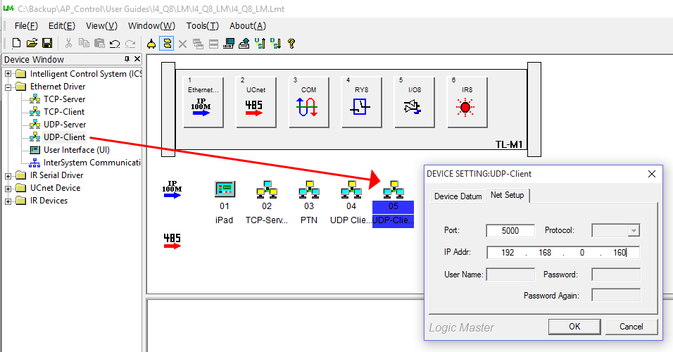

For example, here’s how to make a UDP Client for IR control.

Drag and release the UDP Client as shown in the picture above. Assign port 5000 and default IP 192.168.0.160

Now you need to make a Serial Send module that will send the IR commands to the IR UDP Client. Please refer to the picture below.

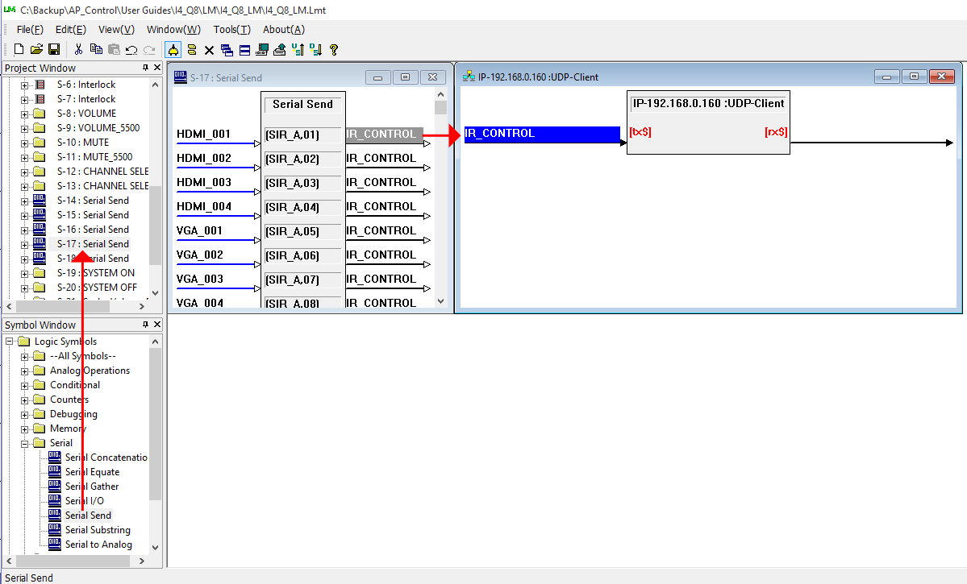

Enter the button triggers on the left of the Serial Send, commands in the center and UDP Client trigger on the right.

Before we can enter the commands in the center we need to know how. Open the I-4 web interface, click Help and then English.

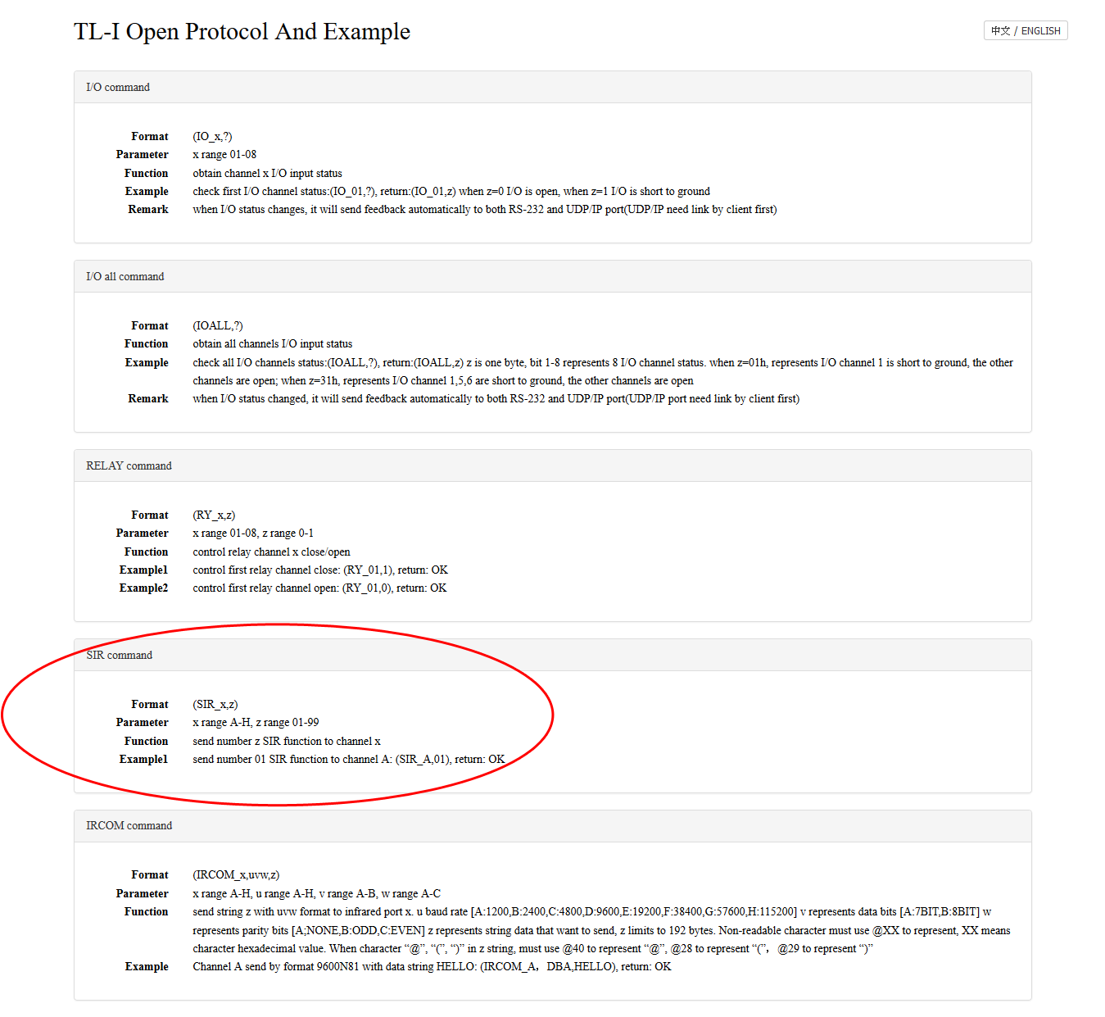

The Format is [SIR_x_z] where x=the IR output port and z=the number of the IR command. For example to send the IR command to switch to HDMI input 1 using IR Output A just enter [SIR_A,01]. The output trigger of the Serial Send in this case is IR_CONTROL and used to trigger the input of the IR UDP Client.

Connecting by UCLink

The I-4 and Q-8 each have a UCLink connector. To connect both units together using the UCLink use a cable with connections as shown below;
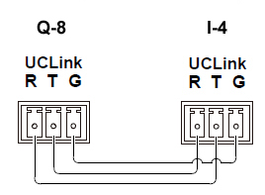

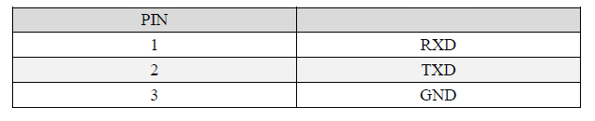
Pins 1 & 2 are crossed over so transmit goes to receive and receive to transmit. Pin 3 Ground is straight thru.

Unlike UDP, the UCLink connection does not require a UDP Client for each protocol nor does it require a unique format command structure.

Programming is the same as for any APAV controller.

I-4 Specifications

Model | I-4
IR Learner | Web Based
TCP/IP Address | 192.168.0.160 default
UDP Port | 5000
Output Ports | 4 Infrared or One-way serial
 | 4 open/close relay
 | 4 digital I/O
Dimensions | 7.25”L x 3.75” W x 2.5” H
Weight | 1 lb.

Q-8 Central Controller output ports

The Q-8 provides 4 RS232 output ports on 5 pin terminal block as shown below.
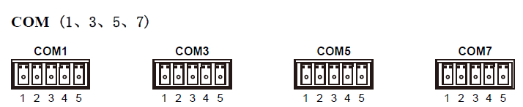

Use the M1 controller in Logic Master to program the Q-8.
COM1 corresponds to COMA of the M1 in Logic Master. COM3 to COMB, COM5 to COMC and COM7 to COMD.
Connections between the Q-8’s COM Ports and DB9 type serial are shown below;
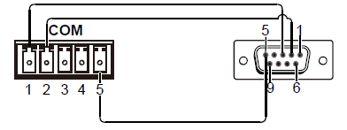
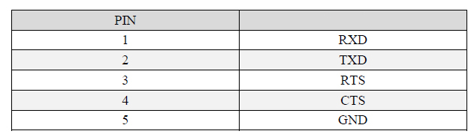
The Q-8 also provides 4 RS232/422/485 outputs on 7 pin terminal block as shown below;
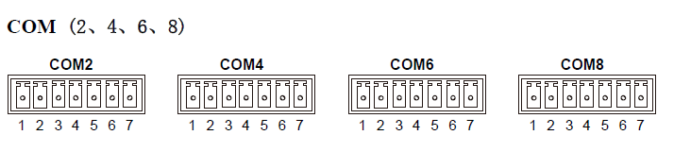
COM2 corresponds to COME of the M1 in Logic Master. COM4 to COMF, COM6 to COMG and COM8 to COMH.

Connections between these Ports and DB9 type serial are shown below;
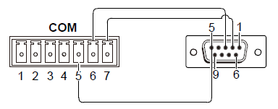
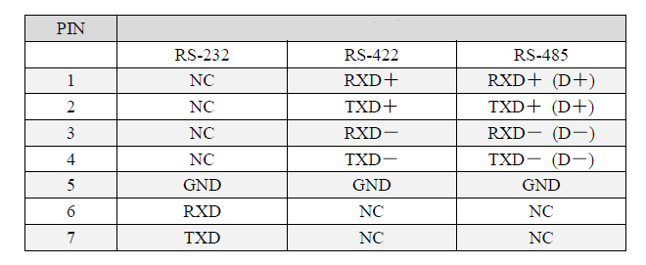

Installation Diagram Q-8 Stand Alone

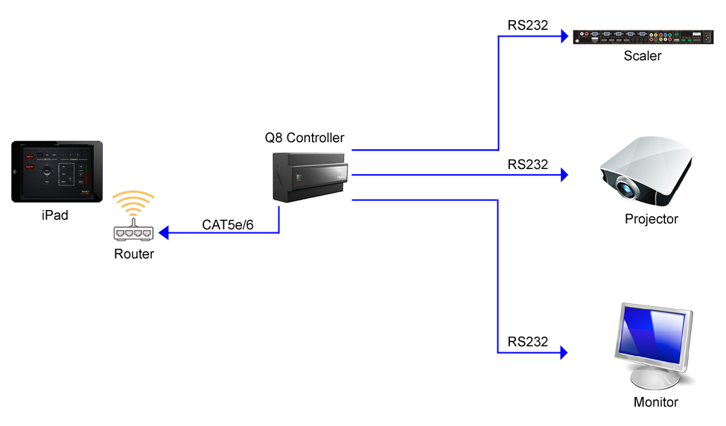

Mounting the I-4 and Q-8

Both I-4 and Q-8 share the identical enclosure supplied with DIN rail mounting hardware and flat surface mounting hardware.
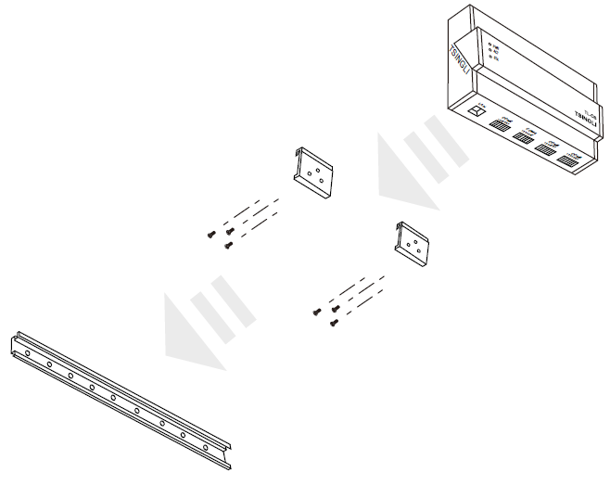
DIN Rail Mounting Hardware

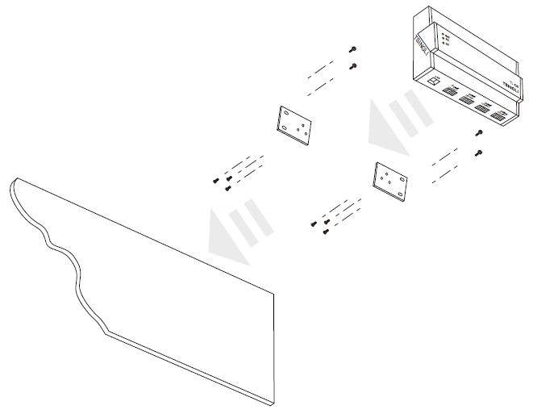
Surface Mounting Hardware

Q-8 Parameters

Like other APAV controllers the Q8 has an internal web server that serves the Vision Master program as HTML pages accessible by web browser device(s).
Up to 3 separate Vision Master program(s) can be stored and served. For example, a program for iPad, another for iPhone and another for PC. Also, there is no limit to the number of devices that can access the program(s).
Each program will have page sizes and screen resolutions unique to the specific device. Screen size and resolution for iPad, for example, is 1024 x 748 (not 1024 x 768). The 20 pixel difference allows for a slim sliver of the Safari tool that can’t be hidden.
The default IP address of the Q-8 is 192.168.0.111 Once a Vision Master program has been downloaded to the Q-8 it can be accessed by opening the web browser and entering the IP address into the URL address bar.
The IP address can also be easily changed in Logic or Vision Master to conform to existing Ethernet(s).
To change the IP address first set the IP address of your computer to something compatible; 192.168.0.100, for example.
Connect from your computer to Q-8 using an Ethernet cable.
In Logic Master on the top tool bar go to Tools and and Device Setting. The Device Setup window will open and there you can change the IP address and click OK to save.
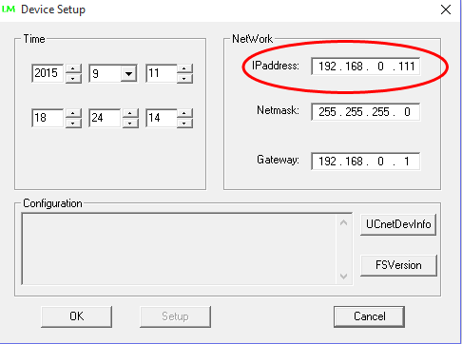

If necessary for whatever reason you can always reset the IP address to default by holding the RST button until the STA light flashes 5 times and then stops.

Q-8 Specs

Model | Q-8
CPU | FREESCALE MCF5125 800 MIPS
MEMORY | 256M DDR2 RAM
UDP Port | 5000
Output Ports | 4 RS232 on Phoenix screw block
 | 4 RS232/422/485 on Phoenix screw block
 | 1 RJ45 Ethernet
Dimensions | 7.25”L x 3.75” W x 2.5” H
Weight | 1 lb.

