M1 Integrated Control Processor
User Guide

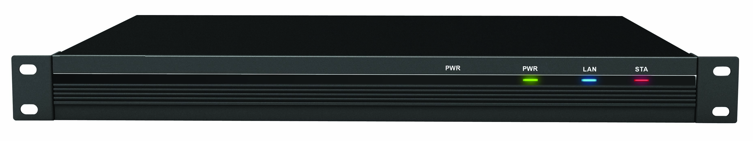

Rev. 1.0

Contents
1 General - 1 -
1.1 Overview - 1 -
2 Programming - 1 -
2.1 Changing the IP address in Logic Master - 1 -
2.2 Using the correct versions of programming software - 4 -
2.3 Creating web pages for the iPad and other web browser enabled devices - 5 -
2.4 Uploading Vision Master program to M1 controller - 6 -
3 Operations - 8 -
3.1 Viewing the program in web browser - 8 -
3.2 Viewing the iPad full screen - 8 -
4 Making Button Templates - 11 -
4.1 Using Style Importer - 11 -
5 Specifications - 14 -
6 Installation - 18 -
6.1 Rack mounting - 18 -
6.2 Ethernet network - 18 -
6.3 Low-speed NET network - 18 -
6.4 Power supply - 19 -
6.5 Correspondence - 19 -
7 Warranty - 19 -

- General
  - Overview
The M1 is a central control integration system for multimedia devices. Through its output ports it’s possible to control devices by means of multiple protocols including RS232 serial, Infrared and Relay. The M1 is programmed using Logic Master software. The software defines output ports to send the correct control protocol to connected devices. The M1 is designed to be used with a touch panel interface. The interface is programmed in Vision Master. Code numbers in Vision Master are assigned to buttons corresponding to codes assigned to buttons programmed in Logic Master. Thus when a button is pressed on the touch panel it will trigger the appropriate response in the M1 and the command sent to the device.
The M1 features an internal web server.
The web server interfaces with any web browser enabled device including personal computers, tablet pc’s, mobile telephones and iDevices like the popular iPad.
Touch panel interfaces are also created in Vision Master, compiled as HTML pages and uploaded to the M1 web server. Once the program is uploaded it can be accessed by opening a web browser and entering the URL address of the controller. By default this address is 192.168.0.111, however, this address, subnet mask and gateway can be changed in Logic Master to integrate into any Ethernet network.

- Programming
  - Changing the IP address in Logic Master

Before you can change the IP address of the M1 controller make a network connection from your computer with an Ethernet crossover type cable or through a router or network switch using standard Ethernet cables.
Since the default IP address of the M1 is 192.168.0.111 you will need to set the IP address of your computer’s network adapter to a compatible address. An example of a compatible address is 192.168.0.114.The subnet mask for these addresses should be set to 255.255.255.0
After making these changes you can verify your connection in the DOS shell by sending the command: ping 192.168.0.111
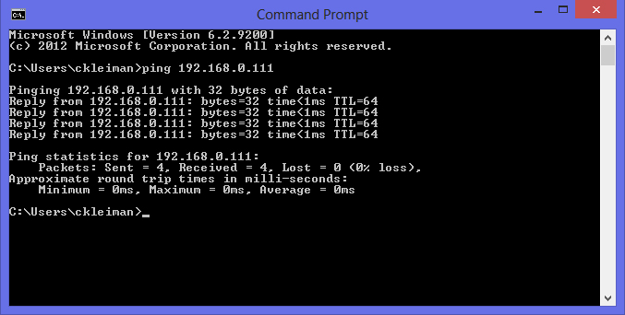
When the M1 replies you know you have a connection.
To communicate from your pc open Logic Master and set the communication setting by going to Tools and Communicate Setting.
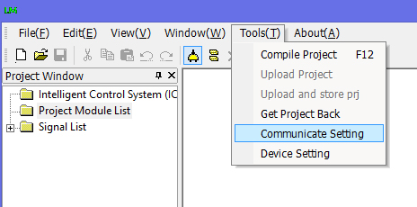

Select TCP/IP and enter the URL address of the M1.

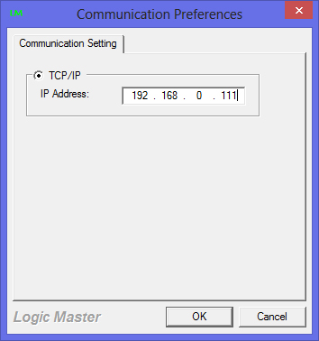

Now go to Tools and Device Setting. If connected properly you will see initializing dig.

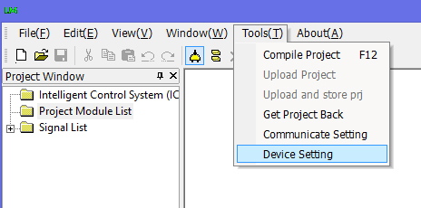

Once the dig is initialized you’ll see the Device Setup window.

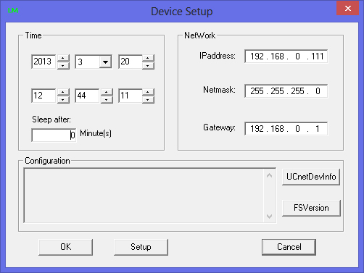

The Device Setup window shows the IP address of the controller, subnet mask and gateway. To change any of these parameters simply enter the new addresses and click OK. The new information has now been stored in the M1.

  - Using the correct versions of programming software
The web server software for the M1 controller is called Browser Support. This software is upgraded from time to time as new features become available. The current version is 3.0 When programming it’s important to know which version of Browser Support the controller is using so you can use the correct versions of Logic and Vision Master when programming.

For optimal performance it's necessary to do as follows:
The BS2.0 need to use software VM , LM 1.4.0 and "File System Version 1.4.0_M1_MUI+_BS2.0_20120515" for TL-M1, they should be match.

The BS3.0 need to use software VM , LM 1.5.0 and "File System Version 1.5.0_M1_MUI+_BS3.0_20130225" for TL-M1, they should be match.

To determine the File System Version you need to connect pc to M1 using Logic Master.....go to Tools and Device Setting. The program will initialize dig and display the window with FS button. Press this button to see the File System Version. (See below)

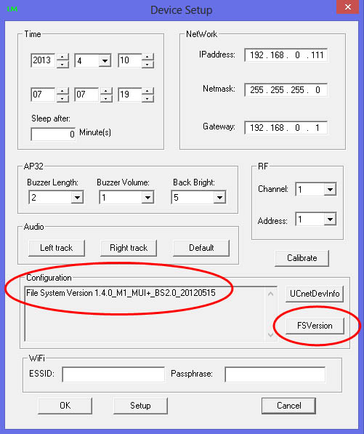

  - Creating web pages for the iPad and other web browser enabled devices
Vision Master software offers the option of creating projects for iPad and iTouch devices in both landscape and portrait mode page sizes.

For example, when creating projects for the iPad in horizontal or landscape mode the page size is set to 1024 x 748 even though the iPad screen resolution is 1024 x 768. The 20 pixel difference allows for a small portion of the tool bar unable to hide in the Safari browser.

To change the page sizes to fit a computer with WXGA resolution, for example, you need to modify the file panel.xml located in the Vision Master installation C:\Program Files (x86)\UnionControl1.5.0-20121221\VisionMaster

Locate the file and open in any editor program.

For example you can change the settings for the iPad in horizontal mode by locating the name TL-iPad-H in the XML file and changing the screen width and height from 1024 x 748 to 1280 x 800 and saving. The next time you launch Vision Master those changes will be remembered so when you choose to create a new project for the iPad in horizontal mode the page size will now change to 1280 x 800.

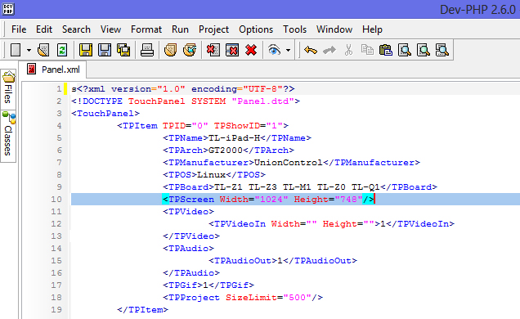

  - Uploading Vision Master program to M1 controller
Your Vision Master project must first be converted into HTML pages before uploading to the M1 server.

Before proceeding it’s necessary to set the communication setting between the M1 and your computer in Vision Master.

Go to Project on the top toolbar and Communication Setting and select TCP/IP and enter the URL of the controller in the same way done in Logic Master.

Click OK. You’re now ready to convert your project to HTML pages by going to the top tool bar and first selecting the Text to HTML button. Once the project is converted you’ll receive the message Web Page generated successfully. Now press the adjacent button to upload.

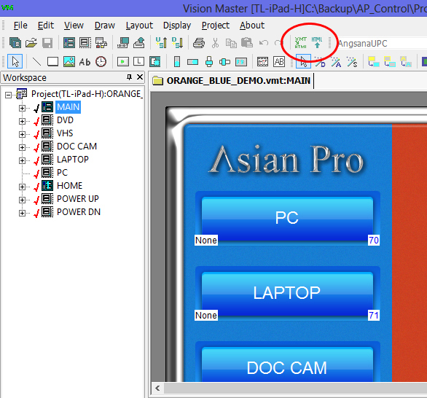

- Operations
  - Viewing the program in web browser
To view your program open your web browser and enter the URL address of the M1 followed by /iPad.html

Assuming the default IP you would enter 192.168.0.111/iPad.html

  - Viewing the iPad full screen
1. First launch your Safari browser and go to the web page you want to view full screen.
2. Tap on the Arrow icon at the top of the screen
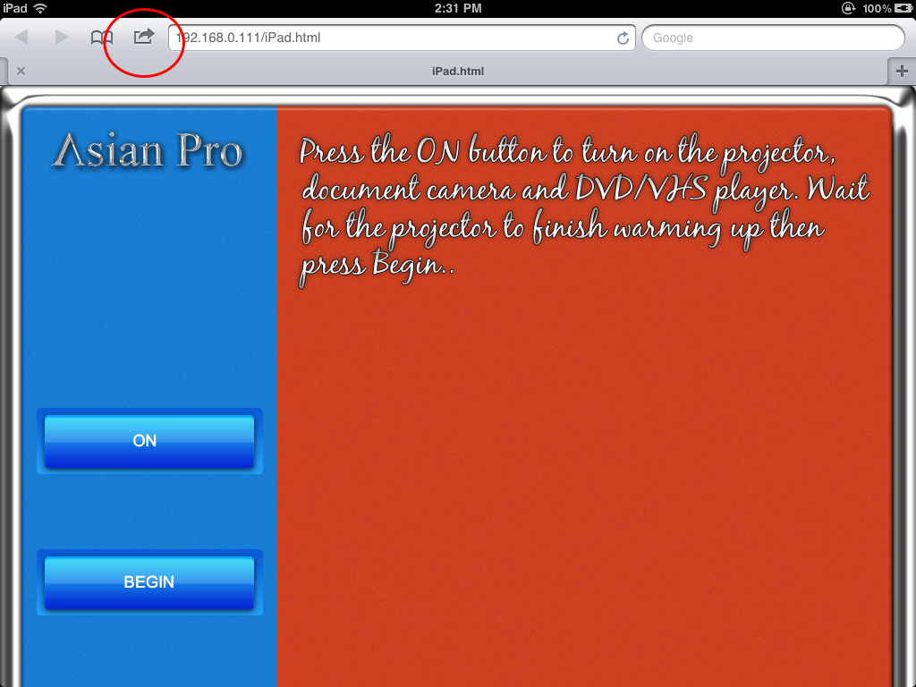
In the drop-down tap on the Add to Home Screen option.
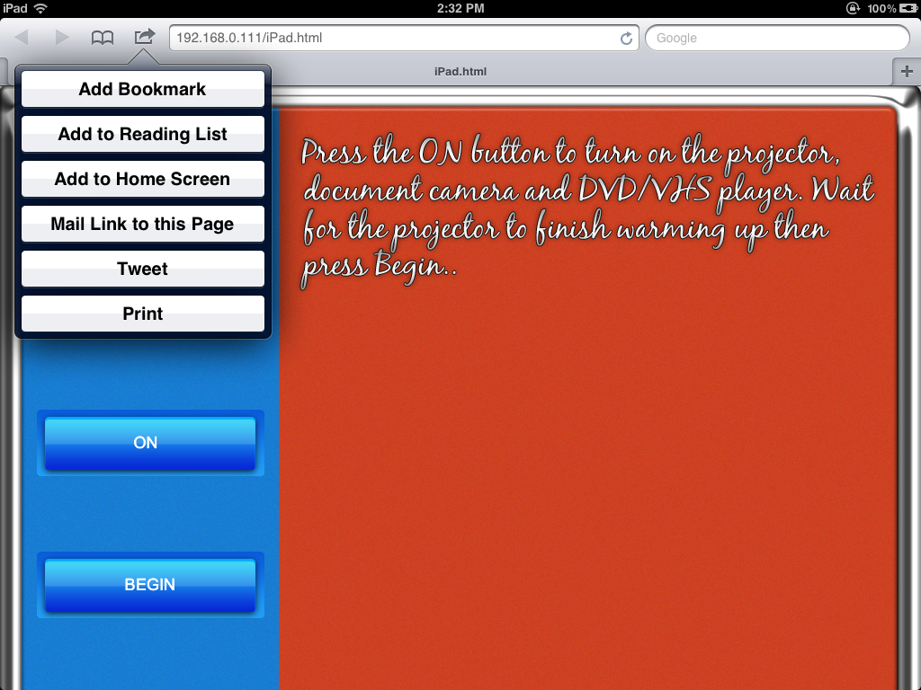
The Add to Home window should be displayed. This will generate a quick launch icon on your desktop. Just type in the desired name and tap the Add button.
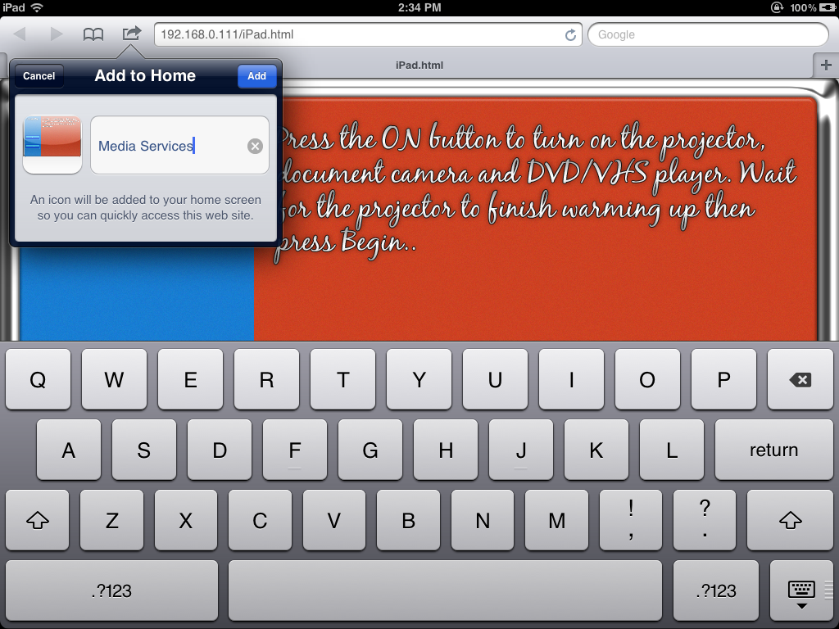
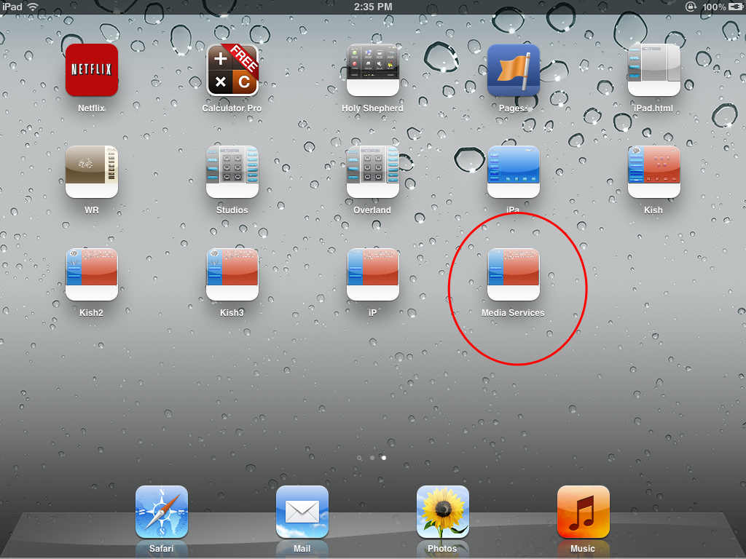
Now you can tap on the icon to view your project in full screen mode.
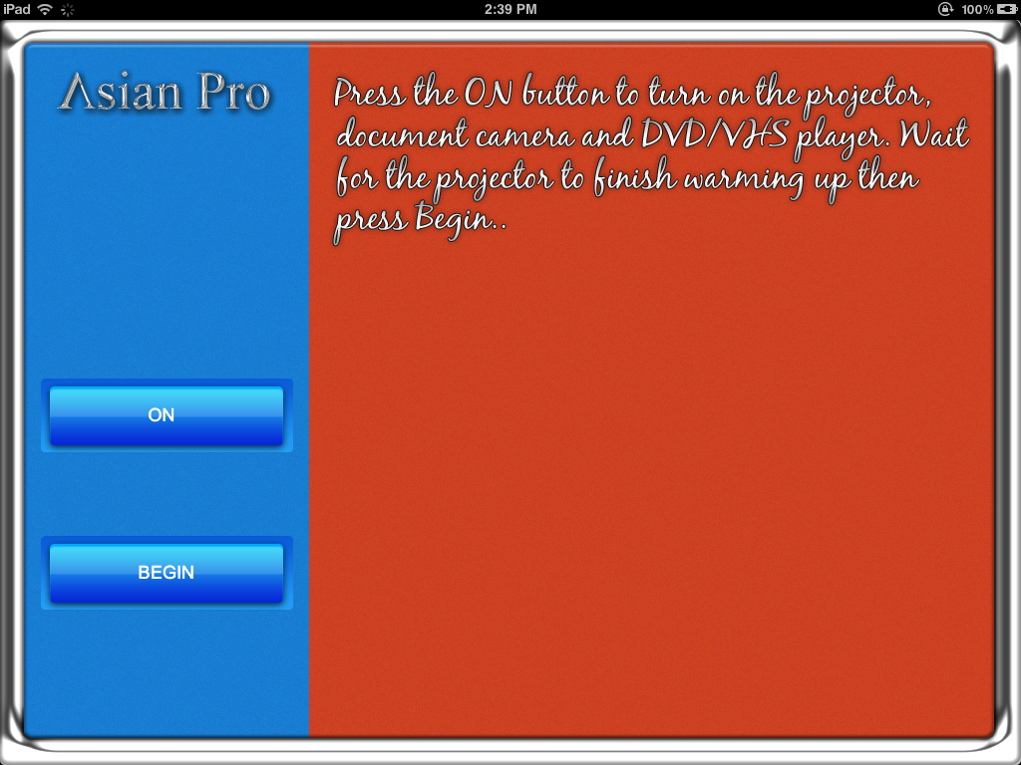
- Making Button Templates

4.1 Using Style Importer
The Vision Master installation includes a library of button templates ready to use in your projects. You can also create your own button templates using the Style Importer utility found in your Vision Master installation; C:\Program Files (x86)\UnionControl1.5.0-20130122\VisionMaster

Double-click on Style Importer to launch the utility. You’ll see the following screen;

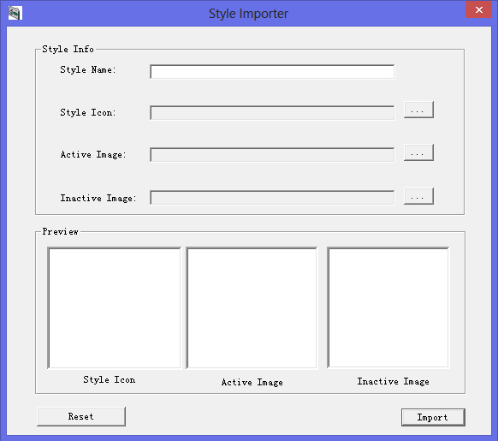

Give the button template a name you’ll recognize in the Style Name box.

Import the style icon found in the Templates folder named icon.png

Import the active button graphic

Import the inactive button graphic

When finished click the Import button. The next time you launch Vision Master you’ll find in your drop-down list of button templates.

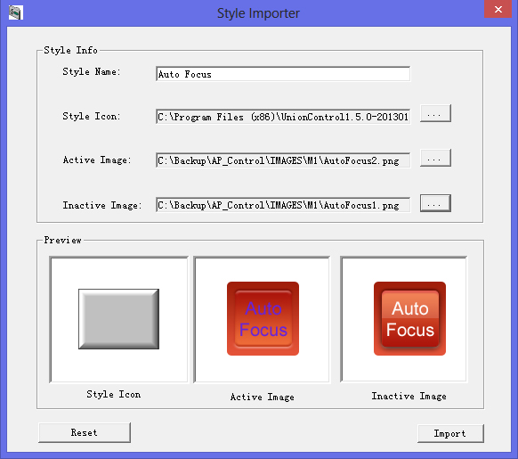

Items | Description
CPU | 32 Bit Freescale MPC5125 800MIPS
CPU, auxiliary | 8 Bit Freescale 68HC908AP32
Memory | 256MB RAM DDR2 memory (1G NAND FLASH)
NET  INFRARED–SERIAL  I/O  RELAY OUTPUT  LAN  COM(A, B, C, D)  COM(E, F, G, H)  24VDC  RST | 1 - Dedicated local low-speed RS-485 network (UCnet)  8 - IR or one-way RS-232 serial port  4 - Programmable digital I/O  8 - Isolated low voltage relay (normally open)  1 - RJ45 10/100M Ethernet interface  4 - DB9 programmable two-way serial communication port (RS-232)  4 - 7PIN programmable serial communication port (RS-232/422/485)  1 - External power input  1 - Reset button
Power supply | 24 VDC, 2A
Ambient temperature  Relatively Humidity (RH) | 5℃ to 45℃  10% to 90%
Dimensions and weight | Height: 45mm  Width: 19 Inch(standard rack)  Depth: 192mm  Weight: approximately 3 kg

- Specifications
The M1 Integrated Control Processor is as shown in the following diagram. It is black in color and texts are printed on both rear and front sides of the device.
LED indicators are located on the front panel and other external connections and Rest button on the rear side.
Front view of M1 integrated control processor:

Rear view of M1 integrated control processor:
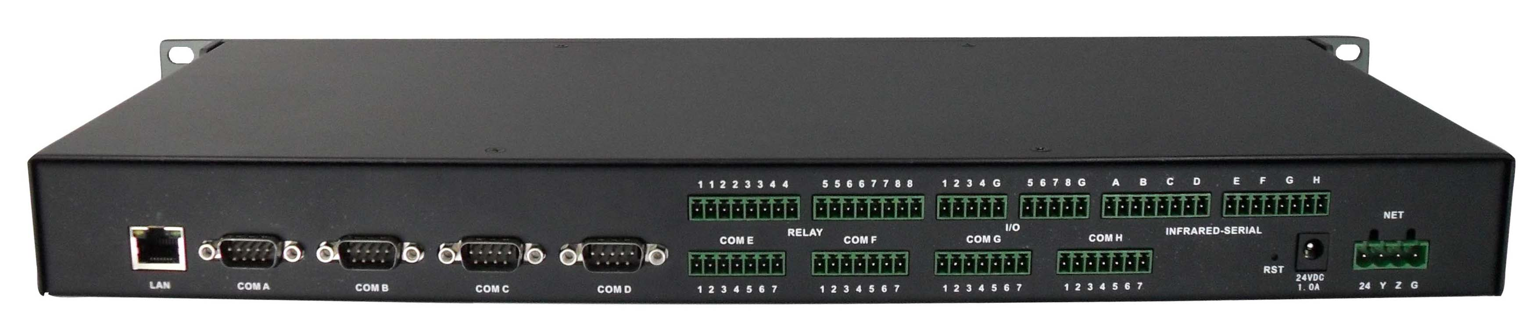

The functions of the LED indicators and RST buttons are as follows:
PWR (Power)
The LED indicator illuminates when the device is connected to an external 24VDC power supply.
RST
The system is automatically reset to factory settings and its IP address 192.168.0.111 when the button is kept pressed for approximately 5sec at the same time when power on. Once it is successfully reset, the IN STA indicator on the front panel flashes five times.
STA
Working Status LED
The functions of the ports are as follows:
COM (A – D)
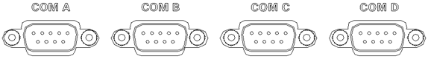

Four DB9 programmable two-way serial ports for common output or input are provided to support RS-232 communication protocol. Max transmission rate reaches 115200bps. IT supports seven standard baud rates between 2,400 and 115,200bps. (Refer to “Logic Master” development program).
Not all the defining of the 9-pin ports is standard. As for RS-232 mode, the configurations of the pins 2 (RXD), 3(TXD), 5(GND), 7(RTS) and 8(CTS) comply with standard assignments of RS-232.
COM (E, F, G, H)
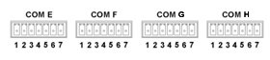

Four programmable two-way complex 7-pin serial ports are provided to support RS-232, RS-422 or RS-485 communication protocol. Max transmission rate reaches 115200bps. IT supports seven standard baud rates between 2,400 and 115,200bps. (Refer to “Logic Master” development program).
Not all the configurations of the 7-pin outputs are standard. As for RS-232 mode, the configurations of the pins 5(GND), 6(RXD) and 7(TXD) comply with standard assignments of RS-232. For RS-422 mode, the assignments of the pins are as follows: 1(RXD+), 2(TXD+), 3(RXD-), 4(TXD-) and 5(GND). For RS-485 mode, pins 1(RXD+) and 2(TXD+) shall be shorted as D+ and 3(RXD-) and 4(TXD-) shall be shorted as D- while Pin 5 is still GND.
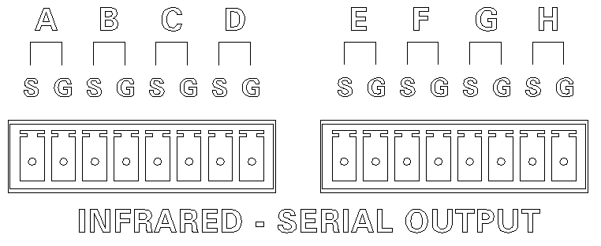 IR – serial input

Each one of the eight ports may serve as an IR output or one-way RS-232 output. S is signal Positive and G is GND. The carrier frequency of IR output is up to 1.2MHz and data transmission rate 115K/s. The amplitude of the output via the one-way RS-232 port is the level of TTL, i.e. 0 to +5V. This is likely inapplicable to control some devices.
Both the data format and transmission rate of the one-way RS-232 can be set in development programs. 7-bit and 8-bit data lengths, five check modes, i.e. N, O, E, M and S and seven standard transmission rates between 2,400 and 115,200bps are supported. (Refer to “Logic Master” development program).
I/O
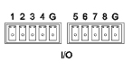

The port provides two programmable 8 channel dry contact input interface and is normally used for detect the signal of the alarm.
RY
Low-voltage relay output
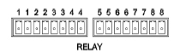

The eight low-voltage relay ports are normally open contacts. Each group is independent and isolated, and can bear a load up to 1A 30VAC/DC.
Power supply

The power input port is used to connect an external 24VDC power supply. When an external 24VDC power supply is input, the NET port also outputs 24VDC power. (The device is applicable to 9-24VDC wide power input.)
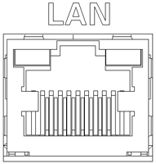 LAN

10/100M Ethernet port and RJ45 terminal are supplied as standard to offer configuration, uploading, network communication and network control and other functions.
A standard cross network communication cable is supplied. The pins of the LAN port are assigned as follows:
PIN | SIGNALS
1 | TD+
2 | TD-
3 | RD+
4 | Connected to pin 5
5 | Connected to pin 4
6 | RD-
7 | Connected to pin 8
8 | Connected to pin7
1 | TD+
The connecting terminals for the NET port, IR serial output port, I/O port and low-voltage relay output port are supplied by the manufacturer.

- Installation
  - Rack mounting
Rubber feet are supplied with the unit in order to place it stably on table top when not mounting it in rack. The unit can also be mounted on a standard rack with the supplied rack mounting bracket.
For rack mounting, the two mounting brackets must be at first installed as shown below. The installation of the rack mounting brackets requires no tools except a standard screw driver.
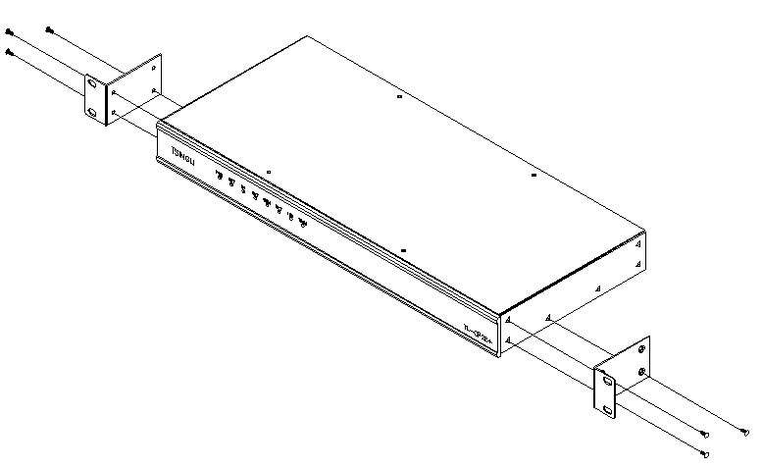

  - Ethernet network
In addition to uploading control program, Ethernet network can be used to cascade several M1 units and control a third party device.
ISC Ethernet communication module is used for programming and linking two or more M1 integrated control processors in a development program. The ISC Ethernet communication module has the function of linking several M1 integrated control processors by means of network communication.
In a development program, the programming with TCP/IP SERVER or TCP/IP CLIENT module may be used to control a third part device and perform the interaction, analysis, creation of any open protocol TCP/IP network data package.
Refer to “Logic Master” programming software for specific functions.

  - Low-speed NET network
The NET connecting port is used to expand UCnet RS-485 network device, e.g. AP-PCI8 Power Supply Controller. When the M1 integrated control processor is connected to an external 24VDC power supply. The NET port outputs 24VDC power supply and be used to supply power to other RS-485 network devices.
A four-wire NET network must be correctly connected. Otherwise the port is subject to damage. Make sure to power down the device before connecting the NET port and clearly identify 24, Y, Z and G that correspond to 24VDC positive, data positive, data negative and 24VDC negative respectively. If the port cascades NET network devices, twisted pair wire shall be used to transmit Y and Z signals to reduce interference.

  - Power supply
The device is supplied with an external 24VDC 2.0A power supply. If this power supply unit is not used, it is likely to connect the 24VDC power supply input port with a power supply with the equivalent parameters supplied by a third party.
The device is applicable to 9-24VDC wide power input.

  - Correspondence
For further assistance, please mailto:sales@apavcontrol.com or directly call us. Our service hotline is 303-881-2615.
Our website: www.apavcontrol.com

- Warranty
APAV warrants the Products to be free of defects in materials and workmanship for a period of three (3) years from the date of shipment except the components stated
below. We pledge to repair or replace defective disk drive or mechanical components requiring adjustment, power supply unit and display elements of touch screen within one (1) year and for touch elements of the touch screen and batteries within 90 days from the date of shipment.
The warranty period shall commence from the date of delivery to user, which shall be recorded in writing.
This warranty does not apply to any defects resulting from any action of Buyer, including but not limited to improper installation, misapplication and mishandling, accidental damage, unauthorized modification and intended damage. In no event will we be liable to you for any damages, including any lost profits, lost savings or other incidental or consequential damages arising out of the use or inability to use the products.
We will, at our sole option, repair or replace defective device or component. Any repaired device or component reserves 90 days of warranty and the warranty period prior to that will automatically become invalid. We reserve the final right to interpret the section.

