APX5500 HD Multiple Input Presentation Switcher Scaler

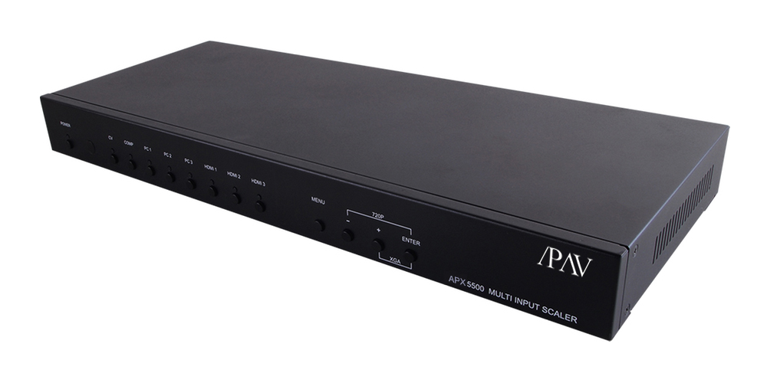

Operation Manual

SAFETY PRECAUTIONS
Please read all instructions before attempting to unpack, install or operate this equipment and before connecting the power supply.
Please keep the following in mind as you unpack and install this equipment:
• Always follow basic safety precautions to reduce the risk of ﬁre,
electrical shock and injury to persons.
• To prevent ﬁre or shock hazard, do not expose the unit to rain,
moisture or install this product near water.
• Never spill liquid of any kind on or into this product.
• Never push an object of any kind into this product through any openings or empty slots in the unit, as you may damage parts inside the unit.
• Do not attach the power supply cabling to building surfaces.
• Use only the supplied power supply unit (PSU). Do not use the PSU
if it is damaged.
• Do not allow anything to rest on the power cabling or allow any weight to be placed upon it or any person to walk on it.
• To protect the unit from overheating, do not block any vents or openings in the unit housing that provide ventilation and allow for sufﬁcient space for air to circulate around the unit.

REVISION HISTORY

VERSION NO. | DATE DD/MM/YY | SUMMARY OF CHANGE
VR0 | 27/06/13 | Preliminary Release
VS1 | 24/07/13 | Updated format/diagrams
VR2 | 08/04/15 | RS-232 Command

CONTENTS
1. INTRODUCTION 4
2. APPLICATIONS 4
3. PACKAGE CONTENTS 4
4. SYSTEM REQUIREMENTS 4
5. FEATURES 5
6. OPERATION CONTROLS AND FUNCTIONS 6
6.1 Front Panel 6
6.2 Rear Panel 7
6.3 Remote Control 8
6.4 RS-232 Protocols 9
6.5 RS-232 and Telnet Commands 10
6.6 OSD Menu 14
6.7 Telnet Control 18
6.8 Web GUI Control 21
6.9 Input Resolution Support 22
6.10 Output Resolution Support 23
7. CONNECTION DIAGRAM 24
8. SPECIFICATIONS 25
9. ACRONYMS 26

1. INTRODUCTION
This Multi Input Scaler has Composite Video, Component Video, PC (VGA), and HDMI inputs and can switch and scale the signal to HDMI or VGA with audio outputs. It supports HDMI output resolutions up
to 1080p/WUXGA and Analog Digital Conversion (ADC) and Digital Analog Conversion (DAC) allowing a wide range of AV signals to be displayed on a HDMI or VGA display. Further, the On-screen Display (OSD), IR remote, RS-232, IP and on-panel controls make this product very versatile.

2. APPLICATIONS
• Analog and digital source integration
• Upscaling standard deﬁnition video for high-deﬁnition displays
• Conference centers
• Lecture halls

• Schools and universities

3. PACKAGE CONTENTS
• Multi Input Scaler
• Remote Control (CR-122)
• IR Extender Cable
• D-Sub to RCA Adaptor Cable
• Power Adaptor
• Operation Manual

4. SYSTEM REQUIREMENTS
Source equipment such as Blu-ray/DVD players or PC/Laptop and output to displays, AV Receivers or active speakers.

5. FEATURES
• Supports switching and scaling of multiple AV inputs to HDMI or PC/ HD outputs
• Supports EDID and HDCP
• Supports 3D de-interlace, noise reduction and 3D comb ﬁlter
• Supports frame rate conversion
• Supports RS-232, IP(Telnet/Web GUI) and IR controls
• Supports output timing hot keys switching
• HDMI compatible with DVI
• Supports Digital to Analog (DAC) and Analog to Digital (ADC) Audio conversion
• Supports Non-HDCP signal of Apple computers

6. OPERATION CONTROLS AND FUNCTIONS

6.1 Front Panel

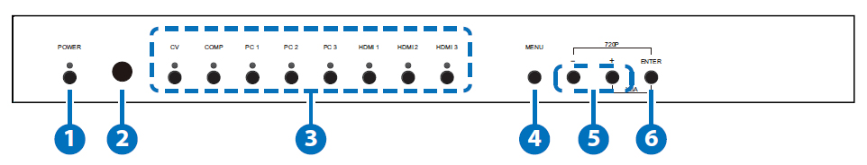
1 POWER Button and LED: Press this button to switch the device on or to set it to standby mode. Once the device is connected to
an active power supply and the Power Switch on the back panel is turned on, the LED will illuminate and the device will switch on automatically.
2 IR Receiver Window: Receives only the IR signal from the remote control included in the package.

3 INPUT Buttons and LEDs: Press these buttons to switch directly to
the required source. An LED will illuminate to indicate the selected
input source.

4 MENU: Press this button to enter the On-screen Display (OSD)
menu.

5 Plus/Minus (−/+) Buttons: Press these buttons to navigate down and up in the OSD menu.

6 ENTER: Press this button to conﬁrm the selection in the OSD menu.
Note: Press this button simultaneously with the '+' (plus) button to instantly switch the output to XGA resolution or with the '−' (minus) button to instantly switch the output to 720p resolution.

6.2 Rear Panel

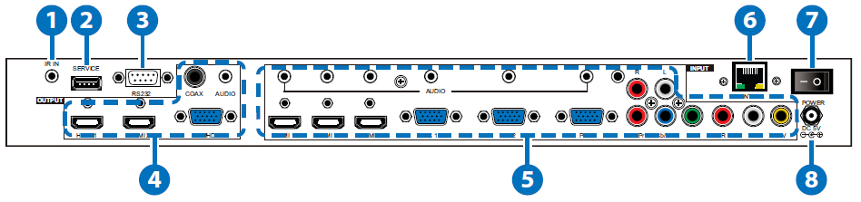
1 IR IN: Connect the supplied IR extender to receive the IR signal from the included IR remote. Ensure that the remote is within the direct line-of-sight of the IR extender.
2 SERVICE: Reserved for manufacturer use only.
3 RS-232: Connect to a PC/Laptop or RS-232 control system to use
RS-232 commands to control the device (See Section 6.5 for details
on RS-232 commands).
4 OUTPUT
1) HDMI 1/2: Connect to an HDMI display or AV Receiver for video and/or audio output.
2) PC/HD: Connect to a monitor/display for video output. For HD (Component) output, use the supplied D-Sub 9pin to 3 RCA adaptor cable for HD resolutions from 480p~1080p.
Note: When the selected HDMI input source signal has HDCP
content the VGA/Component output will not display any image.
3) COAX: Connect to an ampliﬁer or active speakers for audio
output in digital format.
Note: When the input audio source signal is in bitstream format and the AUDIO SOURCE setting is set to AUTO in the OSD menu, the coaxial output will bypass the input audio signal including compatible surround sound formats.
4) AUDIO: Connect to an ampliﬁer or active speakers for audio
output in stereo format.
5 INPUT
1) HDMI 1/2/3: Connect to HDMI sources such as Blu-ray/DVD
player for both video and audio signal conversion.
2) PC 1/2/3: Connect to a PC/Laptop source for video signal input with a D-Sub 15pin cable.

3) 3.5mm Mini-jacks: Connect to source's L/R output with 3.5mm mini-jack for audio signal conversion.
Note: For HDMI signals you can select in the OSD Menu whether you require audio from the HDMI (AUTO) or from the analog audio inputs (EXT)
4) YCbCr/YPbPr + L/R: Connect to source equipment such as a
DVD player for both video and audio signal conversion.
5) CV + L/R: Connect to a composite video source such as a video/DVD player for both video and audio signal conversion.

6 CONTROL: This port is the link for Telnet or Web GUI controls, connect to an active Ethernet link with an RJ45 terminated cable
7 POWER: Switch this power toggle to turn on and activate the device or turn off to shut it down.
8 DC 5V: Connect the power adaptor included in the package to the device and plug it into an AC wall outlet for power supply.

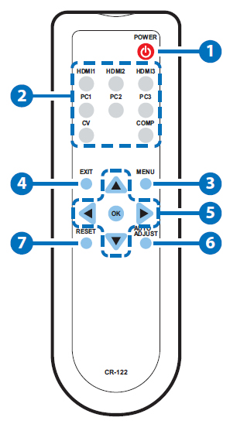
6.3 Remote Control

1 POWER: Press this button to switch the device on or to set it to standby mode

2 HDMI1/2/3, PC1/2/3, CV and COMP: Direct source selection keys. Press one of these keys to switch to the required
source. 4
3 MENU: Press this button to enter the OSD
menu. 7
4 EXIT: Press this button to exit the menu or
the current selection in the OSD menu.
5 OK & ▲▼◄►: Press OK to conﬁrm the selection or press the arrow buttons to navigate the OSD menu. When the OSD menu is not active, use the LEFT/RIGHT (◄►) to control the volume level.

6 AUTO ADJUST: Press this button when the image being outputted does not correctly ﬁt the display's screen. The device will auto adjust the image to ﬁll the screen.

7 RESET: Press this button to reset to the default settings.

6.4 RS-232 Protocols

►
Multi-Input Scaler
PIN | Assignment
1 | NC
2 | Tx
3 | Rx
4 | NC
5 | GND
6 | NC
7 | NC
8 | NC
9 | NC

Remote Control
PIN | Assignment
1 | NC
2 | Rx
3 | Tx
4 | NC
5 | GND
6 | NC
7 | NC
8 | NC
9 | NC

◄

Baud Rate: 19200bps
Data bit: 8 bits
Parity: None
Flow Control: None
Stop Bit: 1

6.5 RS-232 and Telnet Commands

COMMAND | DESCRIPTION
S POWER 0/1  R POWER | 0=OFF 1=ON  Reports the numeric equivalent for POWER  setting (as above)
S SOURCE 1~8  R SOURCE | 1=HDMI 1 5=VIDEO  2=HDMI 2 6=PC 1  3=HDMI 3 7=PC 2  4=YPbPr 8=PC 3  Reports the numerical equivalent for  SOURCE setting (as above)
S OUTPUT 0~21*1  R OUTPUT | 0=640×480 11=1600×1200  1=800×600 12=920×1080  2=1024×768 13=1920×1200  3=1280×768 14=480p  4=1360×768 15=720p6@0  5=1280×720 16=1080i@60  6=1280×800 17=1080p@60  7=1280×1024 18=576p  8=1440×900 19=720p@50  9=1400×1050 20=1080i@50  10=1680×1050 21=1080p@50  Reports the numerical equivalent for  OUTPUT setting (as above)
S SIZE 0~6  R SIZE | 0=OVERSCAN 4=LETTER BOX  1=FULL 5=UNDER 2  2=FOLLOW INPUT 6=UNDER 1  3=PAN SCAN  Reports the numerical equivalent for SIZE  setting (as above)

COMMAND | DESCRIPTION
S INPUT HDCP 0/1  R INPUT HDCP | 0=ON 1=OFF  Apple Computers Only. Reports the numerical equivalent for INPUT HDCP setting (as above)
S SYNCSHIFT 0/1  R SYNCSHIFT | 0=ON 1=OFF  Reports the numerical equivalent for  SYNCSHIFT setting (as above)
S CONTRAST 0~60  R CONTRAST | Sets the numerical equivalent for CONTRAST  setting (0~60)  Reports the numerical equivalent for  CONTRAST setting
S BRIGHTNESS 0~60  R BRIGHTNESS | Sets the numerical equivalent for the  BRIGHTNESS setting (0~60)  Reports the numerical equivalent for the  BRIGHTNESS setting
S HUE 0~60  R HUE | Sets the numerical equivalent for the HUE  setting (0~60)  Reports the numerical equivalent for the  HUE setting
S SATURATION 0~60  R SATURATION | Sets the numerical equivalent for the  SATURATION setting (0~60)  Reports the numerical equivalent for the  SATURATION setting
S SHARPNESS 0~30  R SHARPNESS | Sets the numerical equivalent for the  SHARPNESS setting (0~60)  Reports the numerical equivalent for  SHARPNESS setting
S NR 0~3  R NR | 0=OFF 2=MIDDLE  1=LOW 3=HIGH  Reports the numerical equivalent for the  NOISE REDUCTION setting (as above)

COMMAND | DESCRIPTION
S VOLUME 0~100  R VOLUME | Sets the numerical equivalent for VOLUME  setting (0~100)  Reports the numerical equivalent for  VOLUME setting
S AUDIO DELAY 0~3  R AUDIO DELAY | 0=OFF 2=110ms  1=40ms 3=150ms  Reports the numeric equivalent for the  AUDIO DELAY setting (as above)
S AUDIO MUTE 0/1  R AUDIO MUTE | 0=ON 1=MUTE  Reports the numeric equivalent for the  AUDIO MUTE setting (as above)
S HDMI AUDIO 0/1  R HDMI AUDIO | 0=AUTO 1=EXT  Reports the numeric equivalent for HDMI AUDIO setting (as above)
S KEY LOCK 0/1  R KEY LOCK | 0=ENABLE 1=DISABLE  Reports the numeric equivalent for KEY LOCK setting (as above)
S FREERUNCOLOR 0/1  R FREERUNCOLOR | 0=BLACK 1=BLUE  Reports the numerical equivalent for the free run color setting (as above)
S RESET 1 | Sets the numerical equivalent for RESET  setting (as left)
PORT 0~8 | 0=LAST MEMORY 5=VIDEO  1=HDMI 1 6=PC 1  2=HDMI 2 7=PC 2  3=HDMI 3 8=PC 3  4=YPbPr
ST | Checks the FIRMWARE version and SOURCE  information:  0.00~x.xx  SOURCE: HDMI ~ PC3  PORT ON: LAST ~ PC3
VOL + | Raises the volume level (VOLUME * IS SET)

COMMAND | DESCRIPTION
VOL - | Lowers the volume level (VOLUME * IS SET)
QUIT | Exit. (Telnet Only)

Note:
1. Resolution settings 0~13 are RGB encoded. Resolution settings
14~21 are YUV encoded.
2. RS-232 commands will be not executed unless followed with a carriage return (CR) command and for some systems a Line feed
(LF) command. Commands are case-insensitive.

6.6 OSD Menu

MAIN MENU | SUB MENU | 3RD MENU | 4TH MENU
DISPLAY | OUTPUT | 640×480 60
 |  | 800×600 60
 |  | 1024×768 60
 |  | 1280×768 60
 |  | 1360×768 60
 |  | 1280×720 60
 |  | 1280×800 60
 |  | 1280×1024 60
 |  | 1440×900 60
 |  | 1400×1050 60
 |  | 1680×1050 60
 |  | 1600×1200 60
 |  | 1920×1080 60
 |  | 1920×1200 60
 |  | 1280×720P 60*
 |  | 1920×1080I 60
 |  | 1920×1080P 60
 |  | 720×576P 50
 |  | 1280×720P 50
 |  | 1920×1080I 50
 |  | 1920×1080P 50

MAIN MENU | SUB MENU | 3RD MENU | 4TH MENU
DISPLAY | SIZE | OVER SCAN
 |  | FULL*
 |  | FOLLOW INPUT
 |  | PAN SCAN
 |  | LETTER BOX
 |  | UNDER 2
 |  | UNDER 1
 | MODE INFO | OFF
 |  | INFO*
 |  | ON
 | INPUT HDCP (HDMI mode  only) | OFF
 |  | ON*
 | PC  (PC mode only) | AUTO SETUP
 |  | H_POSITION
 |  | V_POSITION
 |  | PHASE
 |  | CLOCK
 |  | WXGA/XGA | XGA*
 |  |  | WXGA
 |  | RESET
 | TIMING SHIFT | OFF*
 |  | ON

MAIN MENU | SUB MENU | 3RD MENU | 4TH MENU
COLOR | CONTRAST | 0~60 (30)
 | BRIGHTNESS | 0~60 (30)
 | COLOR | R 0~1023 (512)
 |  | G 0~1023 (512)
 |  | B 0~1023 (512)
R OFFSET
0~1023 (512)
G OFFSET
0~1023 (512)
B OFFSET
0~1023 (512)
 | HUE | 0~60 (30)
 | SATURATION | 0~60 (30)
 | SHARPNESS | 0~30 (0)
 | NR. | OFF*
 |  | LOW
 |  | MIDDLE
 |  | HIGH
AUDIO | VOLUME | 0~100 (100)
 | DELAY | OFF*
 |  | 40ms
 |  | 110ms
 |  | 150ms
 | SOUND | ON*
 |  | MUTE
 | SOURCE  (HDMI mode only)*1 | AUTO*
 |  | EXT.

MAIN MENU | SUB MENU | 3RD MENU | 4TH MENU
SETUP | FACTORY RESET*2
 | KEY LOCK | OFF*
 |  | ON
 | POWER SAVE | OFF*
 |  | ON
 | IP MODE | DHCP*
 |  | STATIC
 | SET STATIC IP | IP ADDRESS | 0.0.0.0.~  255.255.255.255*3
 |  | SUBNET MASK | 0.0.0.0.~  255.255.255.255*4
 |  | DEF.GETWAY | 0.0.0.0.~  255.255.255.255*5
 | FREERUN COLOR | BLACK
 |  | BLUE*
INFORMATION | INPUT
 | OUTPUT
 | REVISION
 | IP ADDRESS
Note:
1. When AUDIO SOURCE sets to 'AUTO', if the selected HDMI
input port is connected to an HDMI source, audio signal of the source will be used for output; if the selected HDMI input port is connected to a DVI source, audio signal from the 3.5mm phone- jack on top of the selected HDMI input port will be used. When AUDIO SOURCE sets to 'EXT',only the audio signal from the 3.5mm phone-jack on top of the selected HDMI input port will be used for output.
2. The FACTORY RESET option in the OSD menu will only reset part of settings. For a complete reset of the system, please use the reset button on the remote control.
3. 192.168.0.1 (Default setting).
4. 255.255.255.0 (Default setting).
5. 192.168.0.254 (Default setting).
6. Items in BOLD with an asterisk (*) are the Factory default settings.
Items in brackets are the default values for those settings.

6.7 Telnet Control

Before attempting to use the Telnet control, ensure that both the Scaler (via the LAN port) and the PC/Laptop or control system being used are connected to the same active network.
To access the Telnet control in Windows 7, click on the 'Start' menu and type 'cmd' into the Search ﬁeld then press Enter (see below for reference). Under Windows XP, go to the 'Start' menu and click on
'Run', type 'cmd' then press Enter.
Under Mac OS X, go to the ﬁle menu then navigate to
GoApplicationsUtilitiesTerminal (see below for reference).

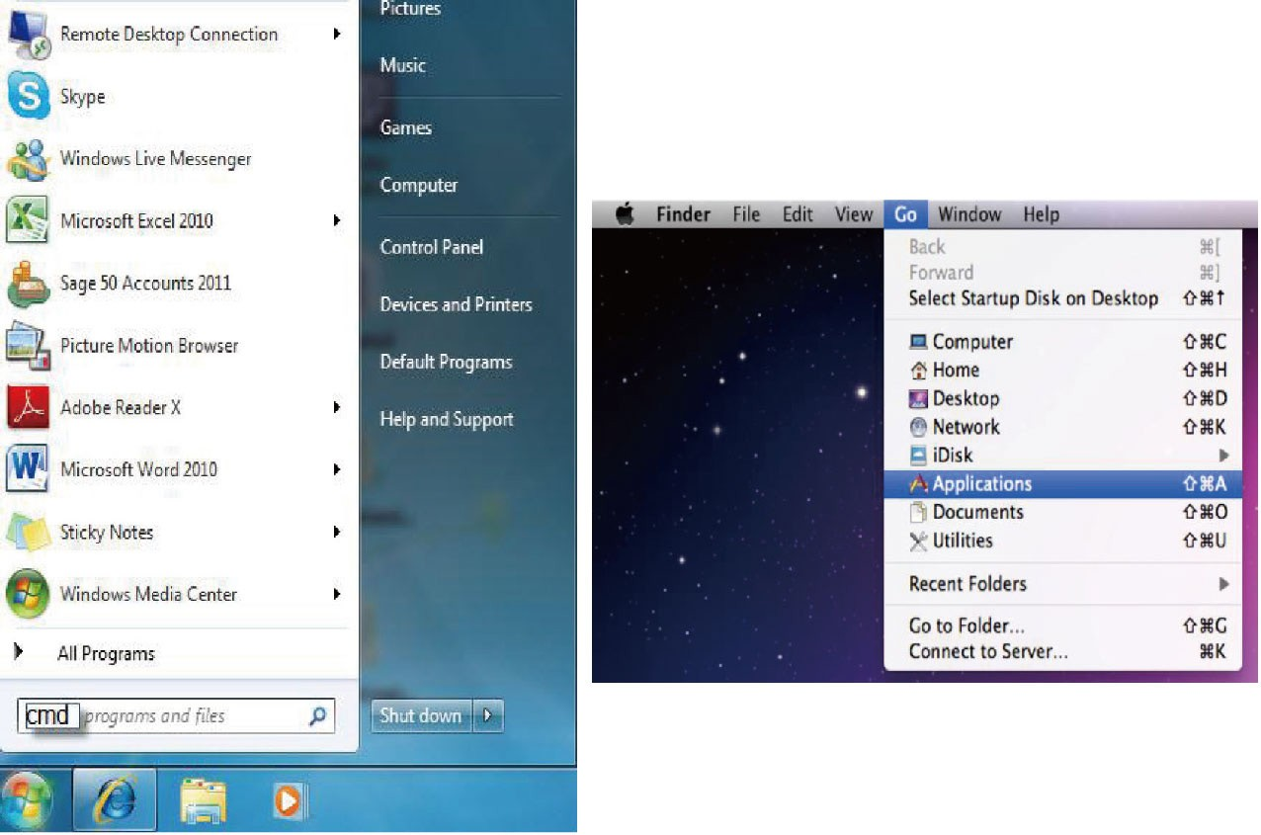

Once in the command line interface (CLI) type 'telnet' along with the IP address of the unit you wish to control (see below for reference). This will bring us into the device which we wish to control.
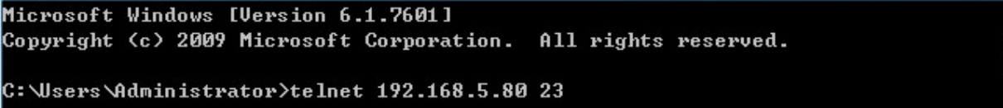
Note: The IP address can be obtained from the OSD menu under Information. If the IP is changed then the IP Address required for Telnet access will also needs to be change accordingly.
Type '?' to list all the available commands (see below for reference).

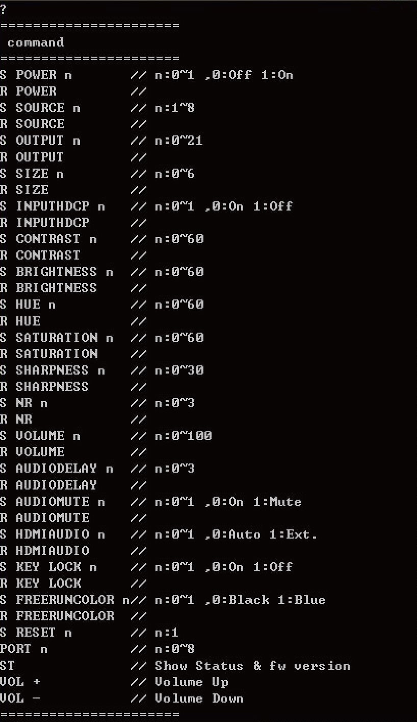
Note: All commands will not be executed unless followed by a carriage return. Commands are case-insensitive.

6.8 Web GUI Control

On a PC/Laptop that is connected to same active network as the Scaler, open a web browser and type device's IP address on the web address entry bar. The browser will bring up the control page of the Scaler (see below for reference).
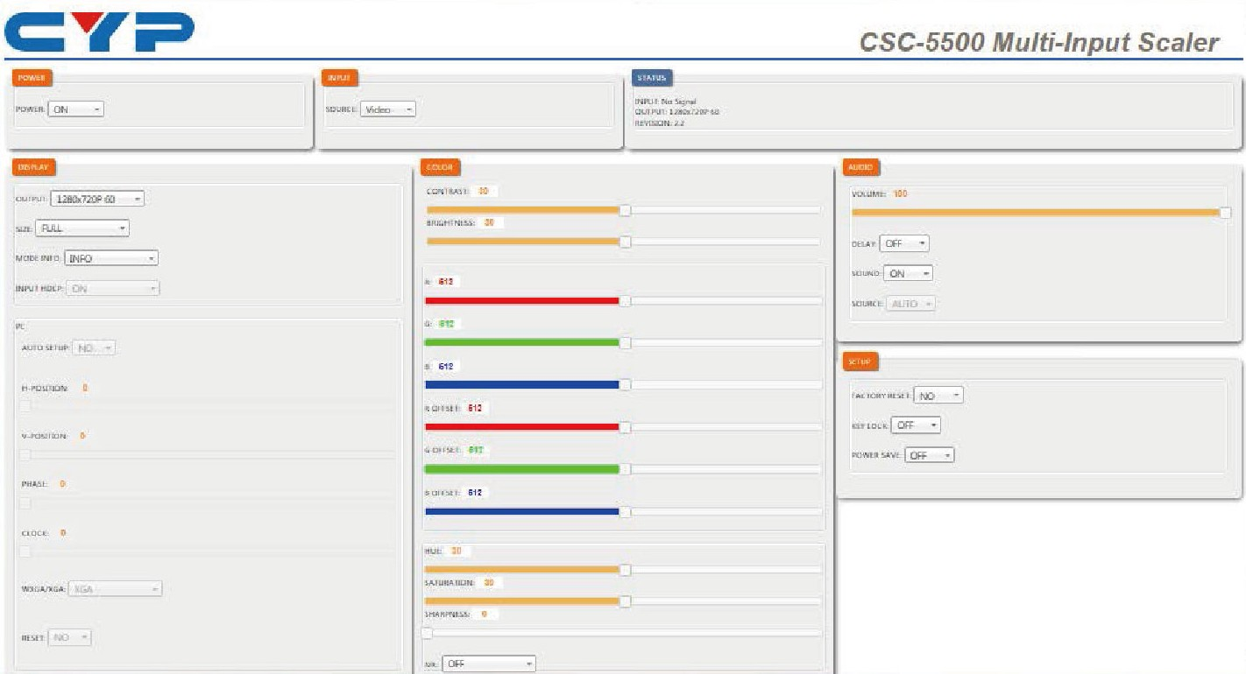

Note: The IP address can be obtained from the OSD menu under Information. If the IP is changed then the IP Address required for Telnet access will also needs to be changed accordingly.

6.9 Input Resolution Support

Input  CV Resolution |  | Component PC HDMI
NTSC/PAL | ✓ | - | - | -
480i/576i | - | ✓ | - | ✓
480p/576p | - | ✓ | - | ✓
720p@50/60 Hz | - | ✓ | - | ✓
1080i@50/60 Hz | - | ✓ | - | ✓
1080p@50/60 Hz | - | ✓ | - | ✓
VGA@60/72/75 Hz | - | - | ✓ | ✓
SVGA@56/60/72/75 Hz | - | - | ✓ | ✓
XGA@60/70/75 Hz | - | - | ✓ | ✓
SXGA@60/75 Hz | - | - | ✓ | ✓
UXGA@60 Hz | - | - | ✓ | ✓
1280×800@60 Hz | - | - | ✓ | ✓
1680×1050RB@60 Hz | - | - | ✓ | ✓
1920×1080@60 Hz | - | - | ✓ | ✓
1920×1200@60 Hz (RB) | - | - | ✓ | ✓

6.10 Output Resolution Support

Output
PC/HD HDMI Resolution
480p/576p | HD | ✓
720p@50/60 Hz | HD | ✓
1080i@50/60 Hz | HD | ✓
1080p@50/60 Hz | HD | ✓
VGA@60 Hz | ✓ | ✓
SVGA@60 Hz | ✓ | ✓
XGA@60 Hz | ✓ | ✓
SXGA@60 Hz | ✓ | ✓
UXGA@60 Hz | ✓ | ✓
1280×768@60 Hz | ✓ | ✓
1280×800@60 Hz | ✓ | ✓
1360×768@60 Hz | ✓ | ✓
1400×1050@60 Hz | ✓ | ✓
1440×900@60 Hz | ✓ | ✓
1680×1050@60 Hz | ✓ | ✓
1920×1200@60 Hz (RB) | ✓ | ✓

7. CONNECTION DIAGRAM

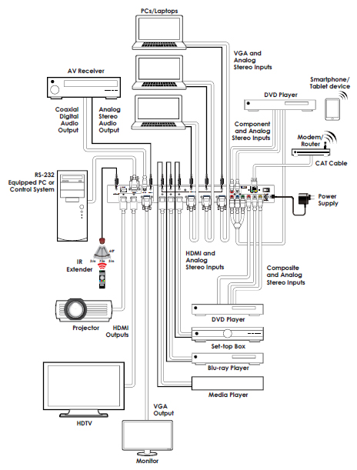

8. SPECIFICATIONS

Input Ports 3×HDMI, 3×VGA, 1×Component Video,
1×Composite Video, 2×RCA (Analog
Stereo L/R), 6×3.5mm Mini-jack,
1×Extender, 1×USB (Service), 1×RJ45
(Control), 1×RS-232 (Control)
Output Ports 2×HDMI, 1×VGA/Component Video,
1×Coaxial, 1×3.5mm Mini-jack
Input Resolution Support Up to UXGA & 1080p
Output Resolution Support Up to WUXGA (RB) & 1080p
Power Supply 5 V/3 A DC (US/EU standards, CE/FCC/
UL certiﬁed)
Dimensions 432 mm (W)×183 mm (D)×47 mm (H)
Weight 2,140 g Chassis Material Metal Silkscreen Color Black
Operating Temperature 0 ˚C ~ 40 ˚C/32 ˚F ~ 104 ˚F Storage Temperature −20 ˚C ~ 60 ˚C / −4 ˚F ~ 140 ˚F Relative Humidity 20 ~ 90 % RH (non-condensing)
Power Consumption 11 W

9. Acronyms
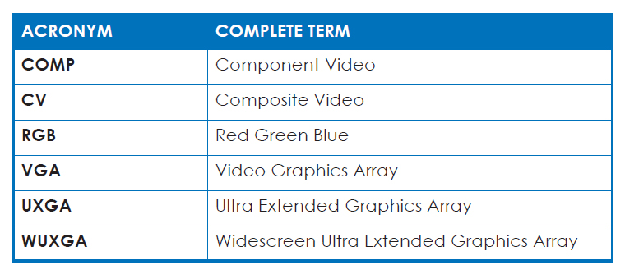

BLANK PAGE END OF DOCUMENT

