Web Browser 3.0

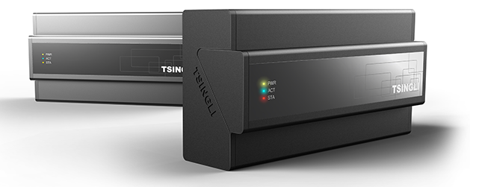

TABLE OF CONTENTS

1. New Vision Master Project 2
2. Accessing your program in the web browser 5
3. Sliding Pages 5
4. View Safari Full Screen 4 Steps 6
5. Locking iPad in landscape mode 12
6. Locking iPhone in portrait mode 12

New Vision Master Project

The current version of Vision Master supports 5 project panel types;

- iPad-H
- iPad-V
- iTouch-H
- iTouch-V
- PC
Where –H is horizontal or landscape mode and –V vertical or Portrait mode
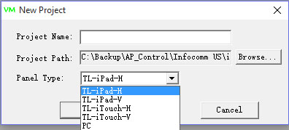

The page size resolution(s) for each device are defined in the Panel.xml file.

The Panel.xml file can be found in the Vision Master installation directory C:\Program Files (x86)\UnionControl1.5.0-20130712\VisionMaster

The Panel.xml file can be modified to make screen size resolutions for other devices

For example, to make a project for the iPhone 6 Plus we see below the screen size resolution is 414 pixels wide by 736 pixels high.

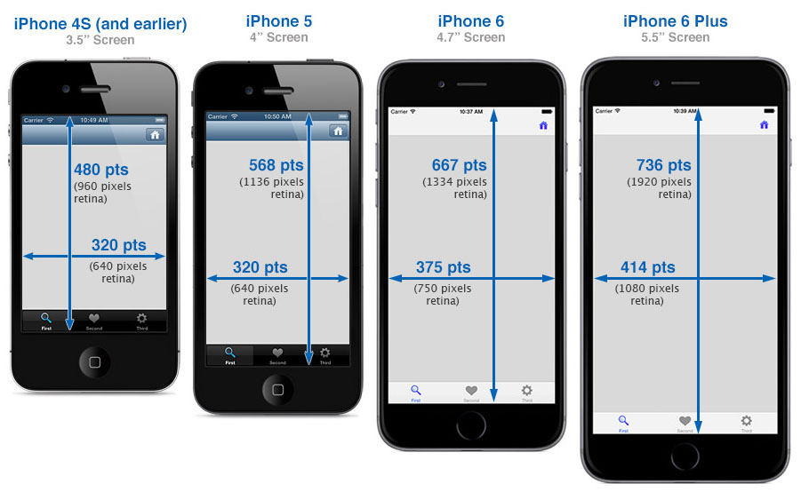
iDevices like the iPhone and iPad can be viewed “full screen” in the Safari Web Browser eliminating the browser’s top tool bar and leaving a 20 pixel sliver of a status bar remaining.

To accommodate the 20 pixel status bar we need to make the page size resolution 414 pixels wide by 716 pixels high.

Since there’s no project option for iPhone 6 Plus in Vision Master we can make a project for PC, but, first we need to change the page size resolution in the Panel.xml file

Open the Panel.xml file using any editor software.

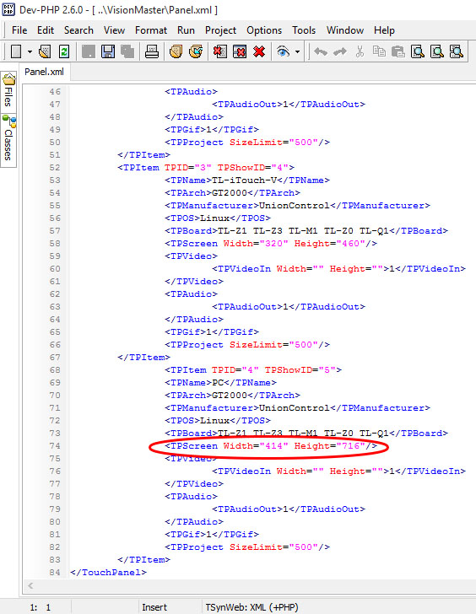

Scroll down the Panel.xml file to PC and change width and height and save.

Restart Vision Master and select PC for your new project. Page size resolutions are now set to 414 x 716

Accessing your program in the web browser

APAV central controllers can store up to 3 unique Vision Master programs.

To access an iPad project open the web browser and enter the controller’s IP address. The default is 192.168.0.111

To access an iTouch project enter 192.168.0.111/iTouch.html

To access a PC project enter 192.168.0.111/PC.html

Sliding Pages

  - supports 5 groups of 10 sliding pages.
The join or code numbers assigned to these groups are as follows;
Group 1: 1800, 1801, 1802, 1803, 1804, 1805, 1806, 1807, 1808, 1809
Group 2: 1810, 1811, 1812, 1813, 1814, 1815, 1816, 1817, 1818, 1819
Group 3: 1820, 1821, 1822, 1823, 1824, 1825, 1826, 1827, 1828, 1829
Group 4: 1830, 1831, 1832, 1833, 1834, 1835, 1836, 1837, 1838, 1839
Group 5: 1840, 1849, 1850, 1851, 1852, 1853, 1854, 1855, 1856, 1857
The lowest number within each group must be set as the start page. For example, if using Group 1 the start page must be coded 1800
Buttons navigating to the sliding pages must have the same join or code numbers. For example, if using Group 1, a “Home” page button must be coded 1800. Pressing this button will take you back to the start page
Navigation buttons are placed on the start page only. They are fixed in position meaning they will appear on every sliding page within the group.

View Safari Full Screen 4 Steps

The Safari Web Browser can be viewed full screen eliminating everything but a 20 pixel status bar sliver at the top.
The steps to view full screen are the same for iPad, iPhone and other iDevices.
Below is an example how to view full screen on the iPhone 6 Plus.

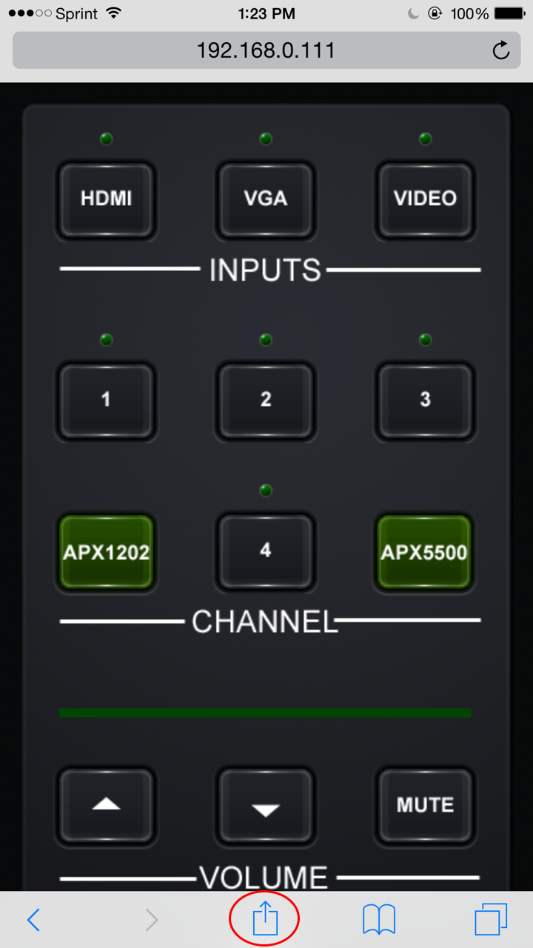
Step 1. Open the Safari Web Browser on your iDevice and enter the URL of the controller Vision Master project 192.168.0.111/PC.html When the program has finished loading press the arrow key bottom
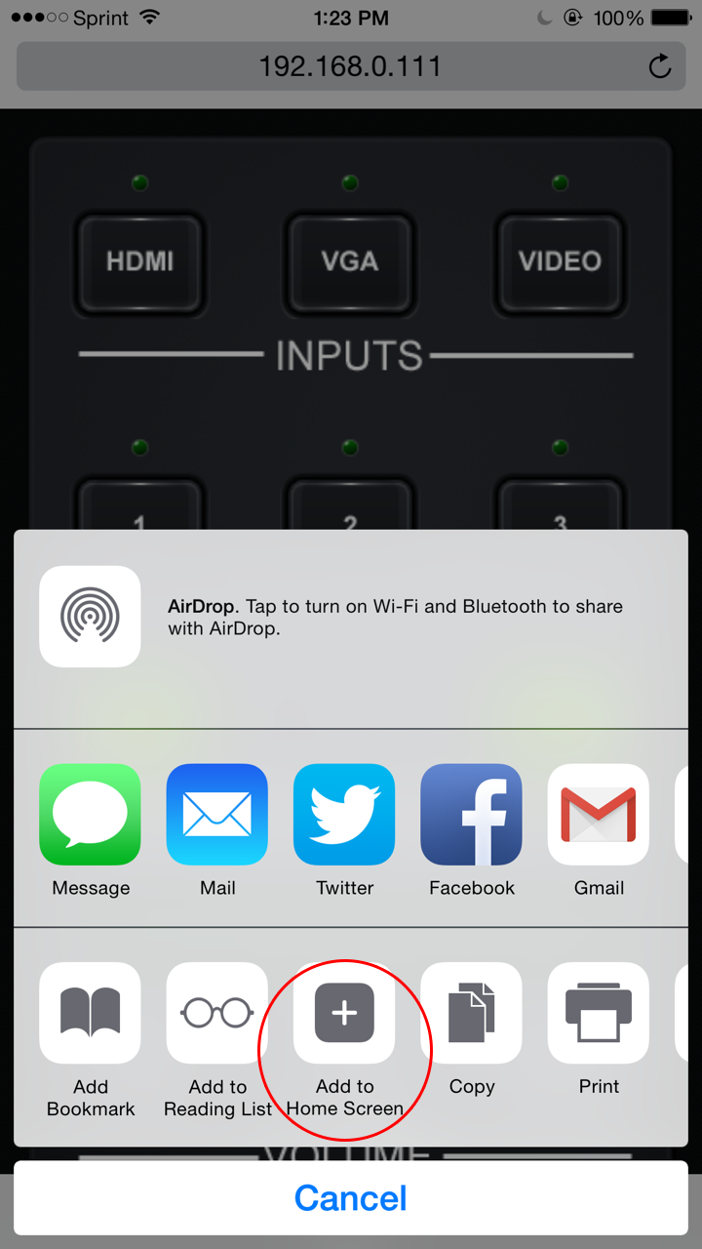
Step 2. Press Add to Home Screen
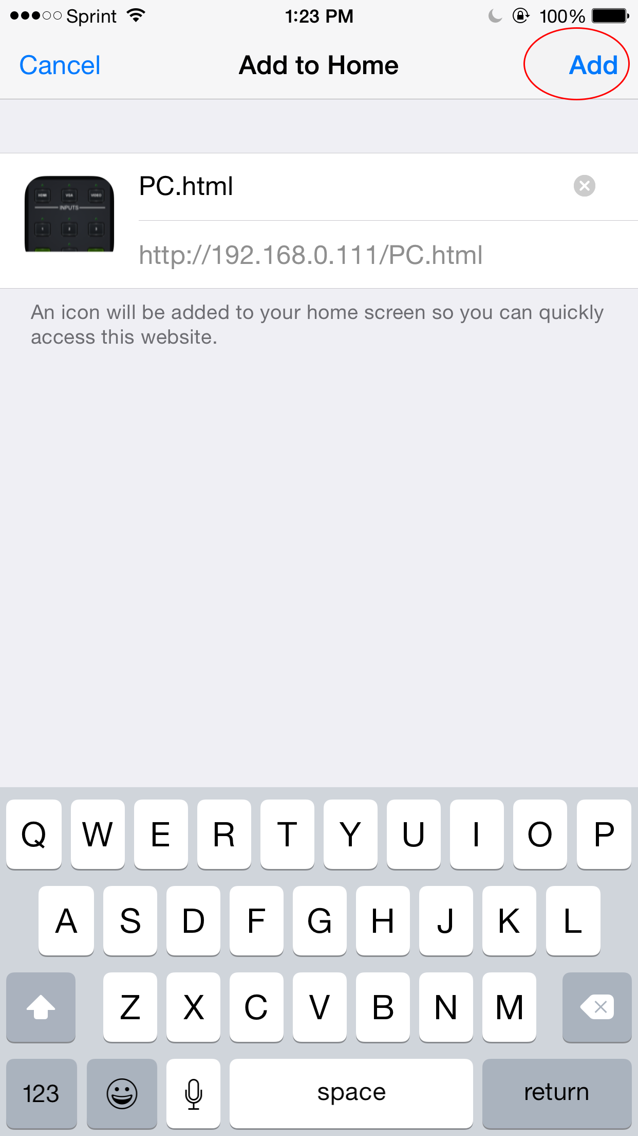
Step 3. Press Add upper right
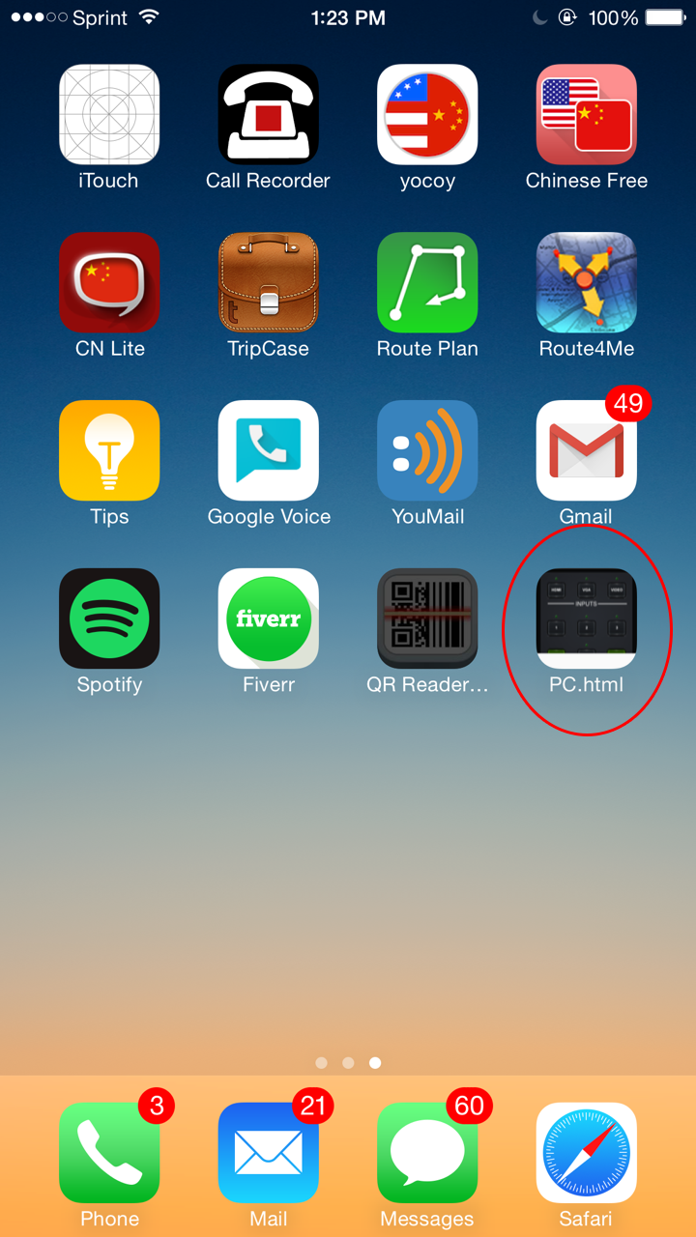
Step 4. Icon created. Pressing it launches program full screen without having to enter URL
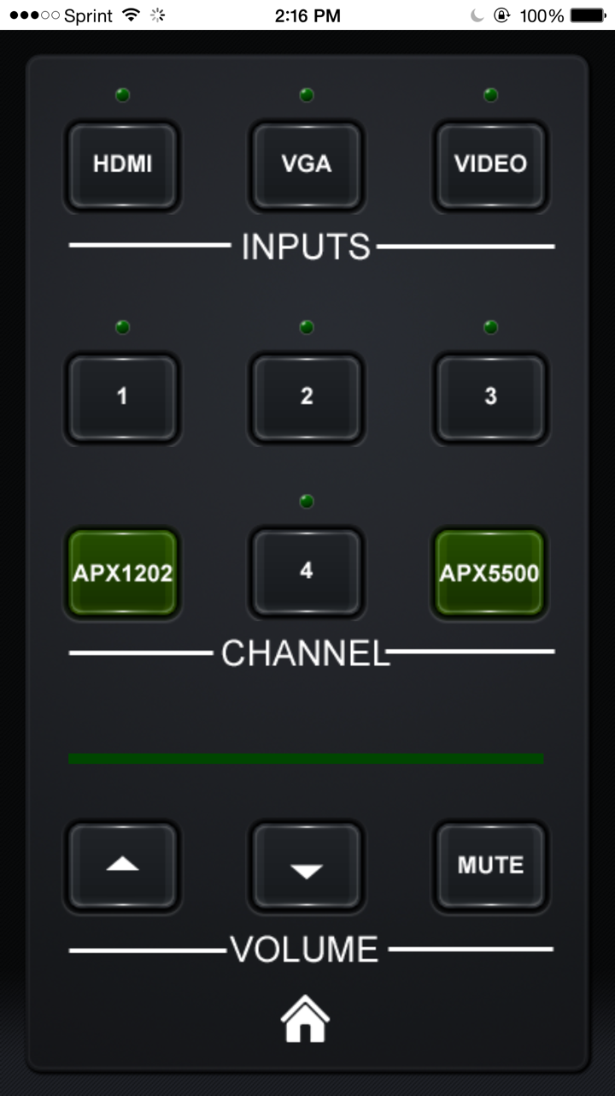
Full Screen Safari with only 20 pixel status bar showing at top

Locking iPad in landscape mode

If you’ve created a horizontal iPad project you will want to lock the iPad in landscape mode to prevent the annoying movement between landscape and portrait mode as the iPad is tilted in use.
To lock in landscape mode double click the Home button and swipe to the right until you see the button far left on the bottom with an arrow inside. Press it once and a lock appears. The iPad is now locked in landscape mode. Pressing, again, removes the lock.
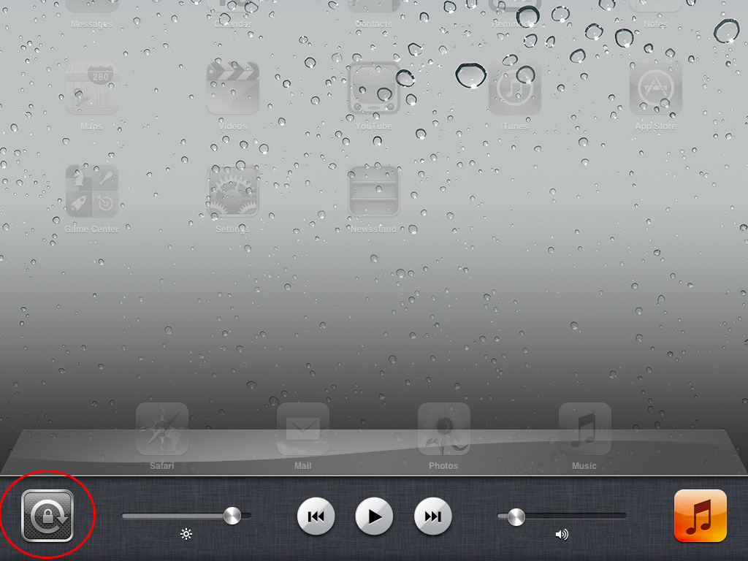

Locking iPhone in portrait mode

Unlike iPads the iPhones cannot be locked in landscape mode. They, can, however, be locked in portrait mode by swiping up from bottom of the screen and toggling the portrait lock button.
