3000 Touch Panel
Operation Manual

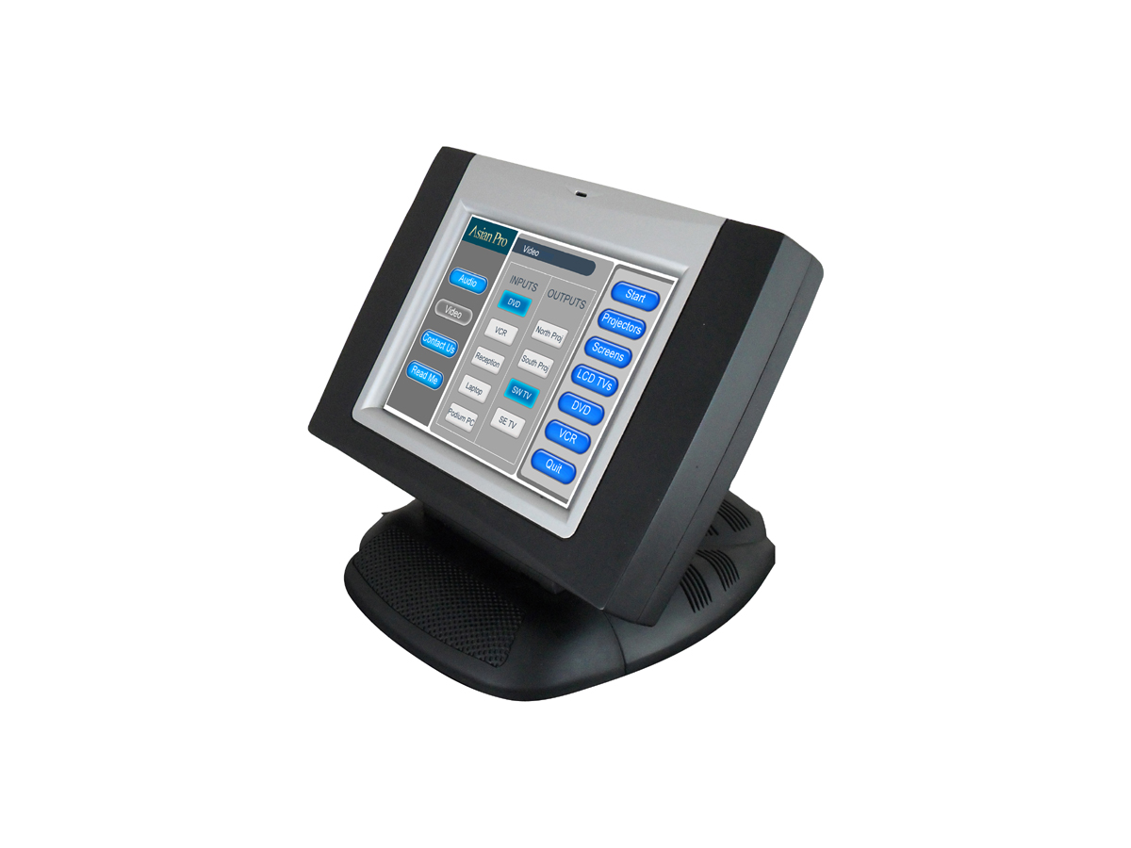

Rev. 1.2

Contents
1 General - 1 -
1.1 Product outline - 1 -
1.2 Specifications - 2 -
1.3 Port description - 2 -
1.4 External dimensions - 4 -
1.5 Ethernet network - 4 -
1.6 Power supply - 4 -
1.7 Switch - 4 -
1.8 Device Setup - 5 -
1.9 Resetting the touch panel to factory default - 8 -
1.10 Troubleshooting checklist - 8 -
1.11 Correspondence - 8 -
2 Warranty - 9 -

- General
  - Product outline
The 3000 can function as a wireless touch panel interface to APAV controllers when used in conjunction with the AP-RFX wireless receiver.
The 3000 can also interface to APAV control systems by TCP/IP network. In this case it functions as a true two-way touch panel interface capable of sending control system commands as well as receiving and displaying device feedback.
The 3000 is custom programmed using Vision Master 1.34 software version (20100825).
Vision Master is a graphics software package used to create the GUI (graphical user interface) for the 3000 and other APAV touch panel interfaces.
Unique backgrounds, windows and buttons can all be created within Vision Master.
Vision Master can also import a variety of graphic file formats including png and jpeg to create custom backgrounds and windows. A Style importer utility allows users to create custom button templates by importing graphics and converting them to buttons.
Code numbers are assigned to buttons and sub-pages in Vision Master to trigger actions in Logic Master programming software.
Logic Master is software used to program the controller processor.
The term program or programming refers to the instructions loaded into the control processor causing it to operate and/or function in a specifically intended manner.

  - Specifications
Specifications of 3000 wireless touch panel
Items | Description
CPU | 32 Bit GT2000 Processor 400MIPS
CPU, auxiliary | 8 Bit Motorola 68HC908AP32
Memory | 192MB(128MB NAND flash, 64MB SDRAM)
Touch film | Four-wire resistance inductive
RF frequency range | 433MHz
RF frequencies | 16 selectable frequencies, interval 400KHz
RF wireless communication | Two-way
Range of RF wireless communication | Open area: 100m; indoor: 70m
AC97 audio | Programmable audio output
Display size  Resolution  Brightness  Color | 6.4”  640*480  250cd/m2  True-color, 18 bits, 2.6M
Contrast  Viewing angle  LAN  Power supply  Outside colors | 300:1  Left and right: 45°45°; Up and down: 35°15°  RJ45 10/100M Ethernet  24VDC 2A charge power supply input  Silver and black
Power consumption | 5W (typical)
Ambient temperature  Relatively Humidity (RH) | 5℃ to 45℃  10% to 90%
Dimensions | (See below)

  - Port description
The 3000 wireless touch panel is as shown in the following diagram. It is silver and black in color and all external interfaces and buttons are on the rear side of the device.

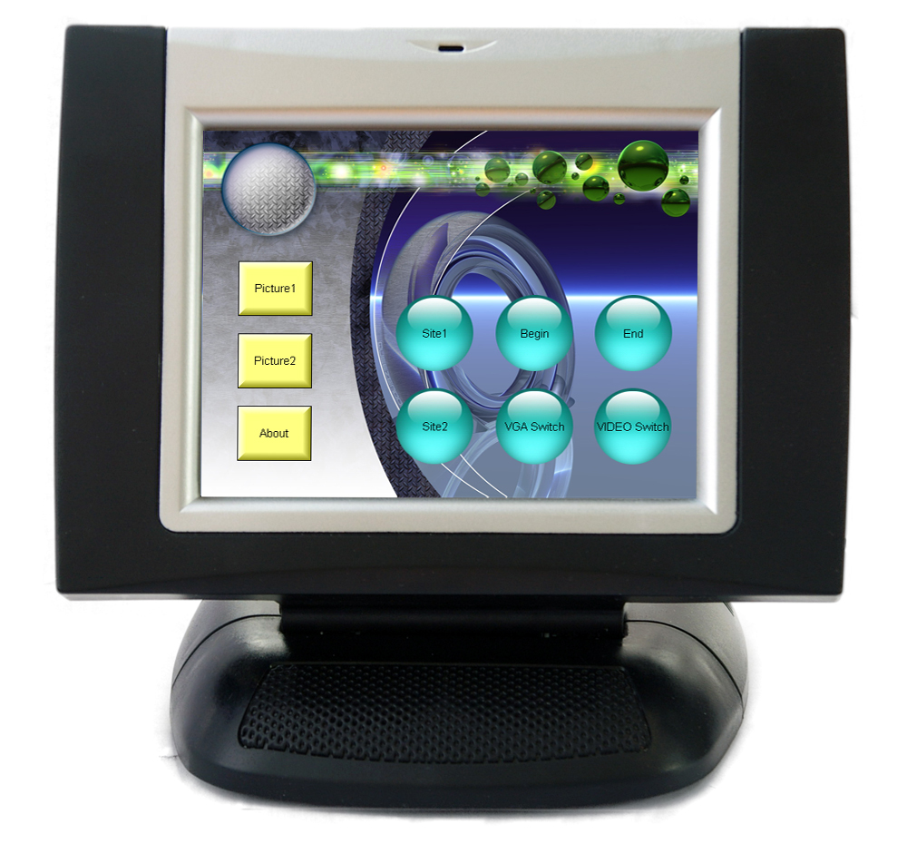

Front view of 3000 wireless touch panel

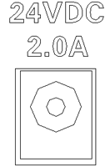The functions of the ports are as follows:
Power supply

The device is supplied with a 24VDC 2A external charge power supply which is used to charge the built-in lithium battery pack. It takes approximately 8 hours to charge it to maximum voltage.
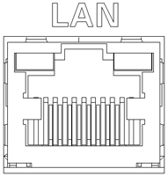 LAN

10/100M Ethernet port and RJ45 terminal are supplied as standard to offer configuration, uploading, network communication and network control and other functions.
A standard cross network communication cable is supplied. The pins of the LAN port are assigned as follows:
PIN | SIGNALS
1 | TD+
2 | TD-
3 | RD+
4 | Connected to pin 5
5 | Connected to pin 4
6 | RD-
7 | Connected to pin 8
8 | Connected to pin7
1 | TD+

  - 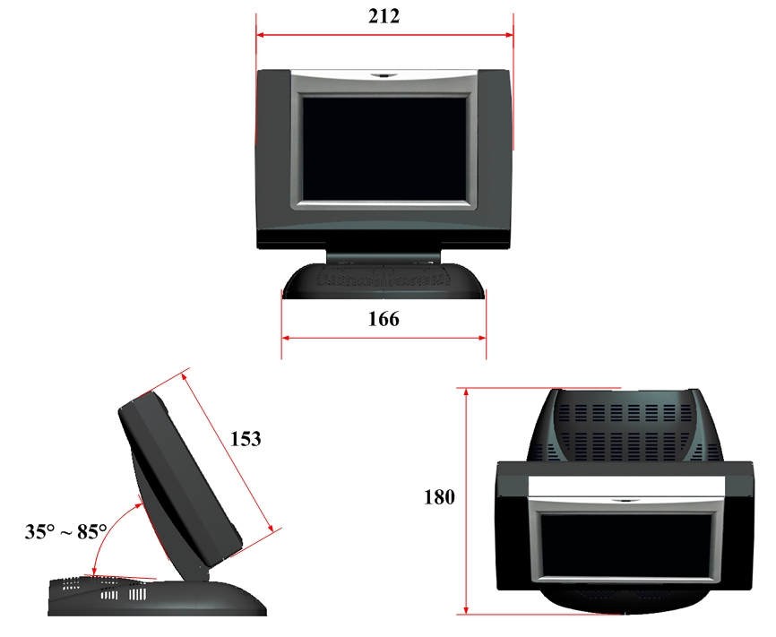 External dimensions

(Unit: mm)
  - Ethernet network
The Ethernet port of the 3000 wireless touch panel is used to upload programs. Its factory default IP address is 192.168.0.111.

  - Power supply
The power interface is used to input external power supply and charge the built-in lithium battery.

  - Switch
The touch panel enters into normal operating state when the switch is pressed. When it is left unused for an extended period of time or during long-distance transport, the switch shall be turned off in order to protect the battery and the related circuit. When the switch is turned on, the system takes approximately 30 seconds to start. It is not necessary to turn off the switch during normal operation.

  - Device Setup
All parameters of the touch panel can be set via the “Project/Device Setup” option in “Vision Master”.
The factory default IP address of the 3000 is 192.168.0.111
To open the Device Setup window connect your pc to the 3000 by network either directly using an Ethernet cross-over cable or through a network switch using a standard Ethernet cable.
Next set your PC’s network adapter to a compatible IP address. For example: 192.168.0.112
In Vision Master go to Project on the top tool bar and Communication Setting and enter the IP address of the 3000 touch panel.
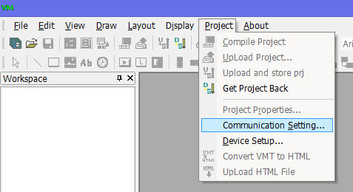

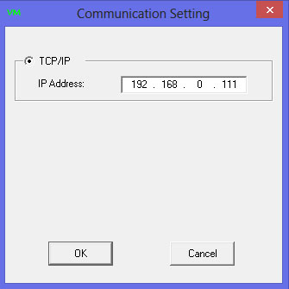

Now go back to Project on the top tool bar and select Device Setup

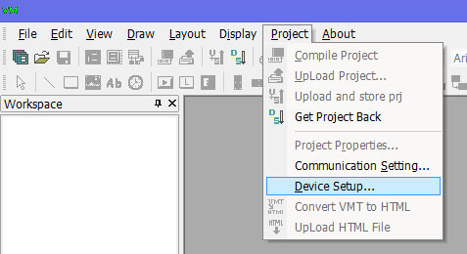

Assuming you’re connected by network “Initializing Dig” will take place and the Device Setup Window will appear;

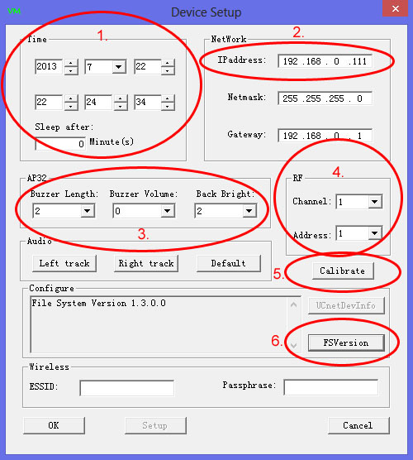

The Device Setup window allows us to configure the parameters of the 3000.

- Sets the date as follows; year, month, day and the time as follows: hours, minutes, seconds. Also set the sleep settings for the panel to go to black screen or “sleep”. Pressing anywhere onto the touch screen will awaken the panel from the “sleep” state. Setting to 0 will prevent panel from going to “sleep” state.
- The IP address of the touch panel. The address can be changed here and pressing OK will save the changes.
- Turn OFF button “beeps” by setting Buzzer Volume to 0 from the drop down box or turn ON by setting Buzzer Volume to setting from low to high volume (1-3) and the length of the beep Buzzer Length from short to long (1-3). Set the backlight level of the LCD display from low to high (1-5).
- If operating the 3000 as a wireless touch panel set the channel (1-16) and address (1-16)
- Calibrate the 3000 screen. Pressing this button will cause 3 circled crosshairs to appear on the touch panel. Press the red highlighted crosshair upper left first then follow by pressing the next highlighted crosshair then the next until the calibration is complete.
- Obtain the current file system version OS

  - Resetting the touch panel to factory default
For whichever “Logic Master” or “Vision Master”, communication with the 3000 wireless touch panel must be established before unloading a program. At first, connect a PC to the 3000 wireless touch panel with the cross network cable. Then set the factory default IP communication address: 192 .168.0.111. The PING command in the PC may be used to check that the communication network is established. It is also possible to directly connect it to a LAN through a HUB with the “straight through” network cable.
When the IP address of the current device is unknown, restart it and keep the touch panel pressed for approximately 5 seconds. The system will give five short beeps and automatically restore the factory settings when the settings are successfully recovered. The IP address is 192.168.0.111 by default.

  - Troubleshooting checklist
Symptom | Possible cause | Solution
The touch panel does not display. | The switch button is not pressed down. | Press down the switch button.
 | The touch panel is in sleeping state. | Gently touch the touch panel to exit from the sleeping state.
 | Inadequate voltage. | Connect it to external power supply to charge the batteries.
The touch panel does not give any sound. | Erroneous program | Check and rectify the program.
 | Excessively low volume | Adjust the output volume with software.
Communication cannot be established. | Communication cable not connected | Check that network cable is securely connected to target device.
Compiled program cannot upload | The program is not saved. | Check and save the program.
 | Erroneous program | Check and rectify the program.
Note: Contact your dealer for other troubles.
  - Correspondence
For further assistance, please email to sales@apavcontrol.com or directly call us. Our service hotline is 303-881-2615.
Our website: www.apavcontrol.com

- Warranty
APAV warrants the Products to be free of defects in materials and workmanship for a period of three (3) years from the date of shipment except the components stated below. We pledge to repair or replace defective disk drive or mechanical components requiring adjustment, power supply unit and display elements of touch panel within one (1) year and for touch elements of the touch panel and batteries within 90 days from the date of shipment.
The warranty period shall commence from the date of delivery to user, which shall be recorded in writing.
This warranty does not apply to any defects resulting from any action of Buyer, including but not limited to improper installation, misapplication and mishandling, accidental damage, unauthorized modification and intended damage. In no event will we be liable to you for any damages, including any lost profits, lost savings or other incidental or consequential damages arising out of the use or inability to use the products.
We will, at our sole option, repair or replace defective device or component. Any repaired device or component reserves 90 days of warranty and the warranty period prior to that will automatically become invalid.
We reserve the final right to interpret the section.

